CONFIDENTIAL/DRAFT
Final Results Of Municipal Governance Survey - Aug 14, 2025
Agree/Disagree

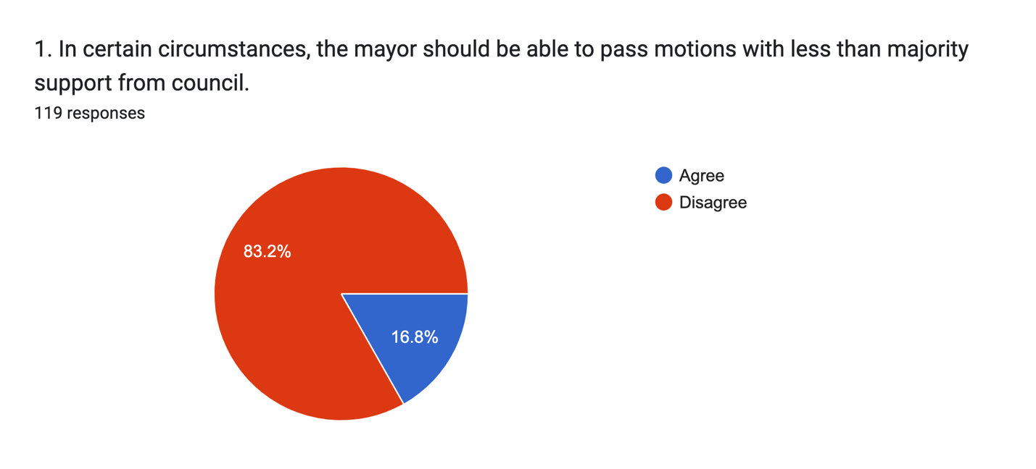

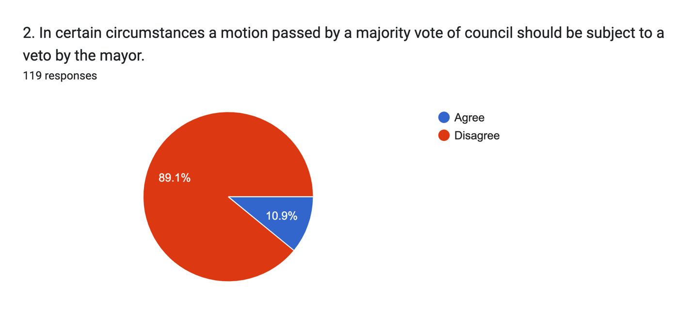
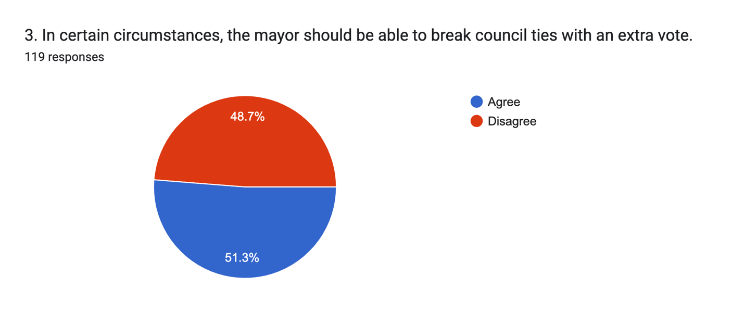

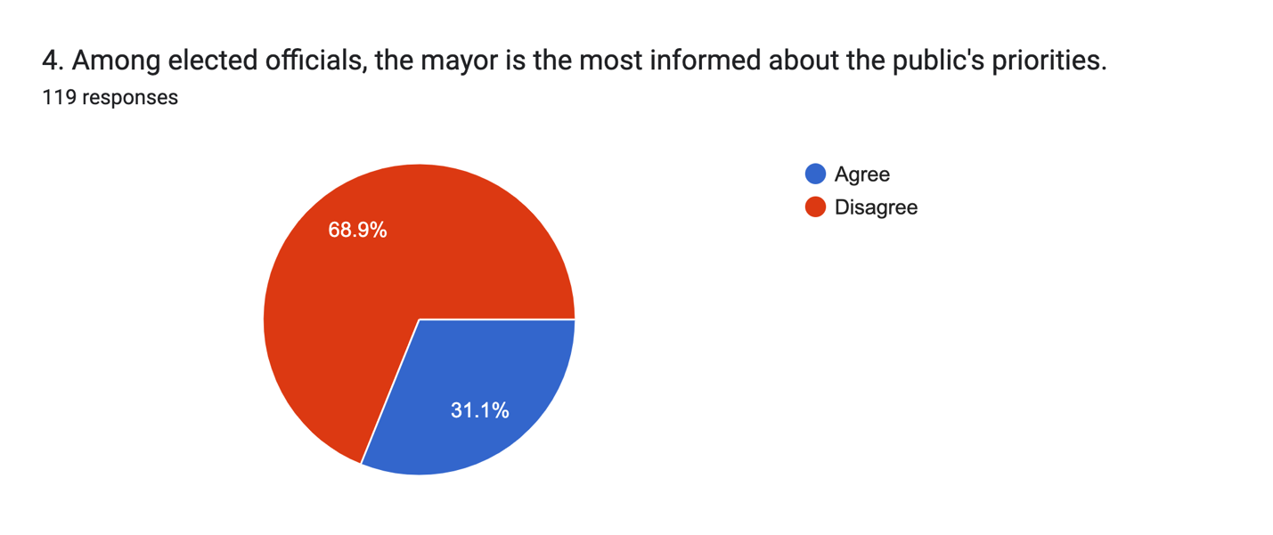
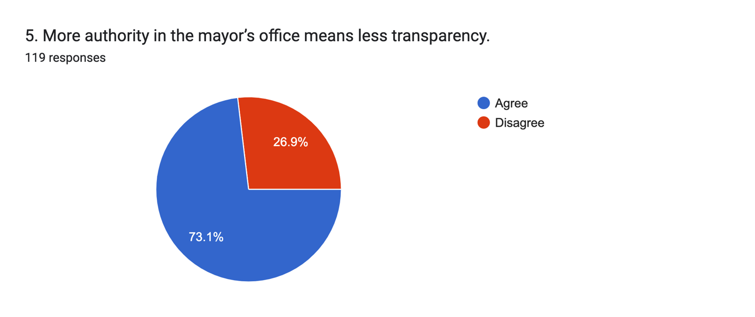

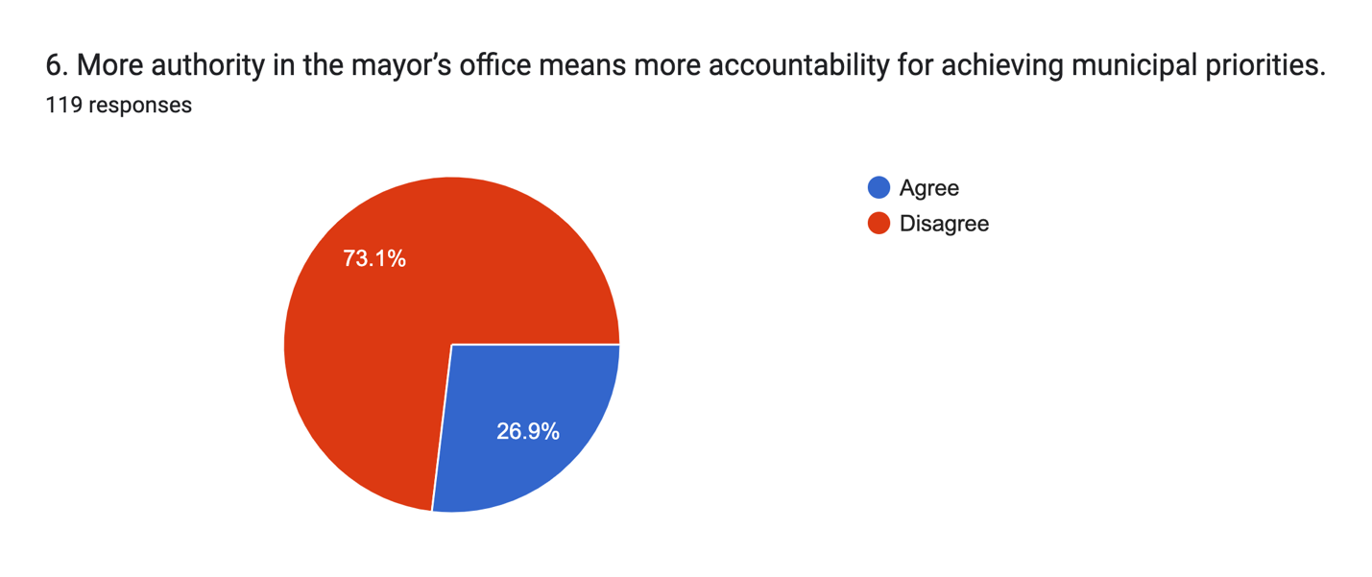
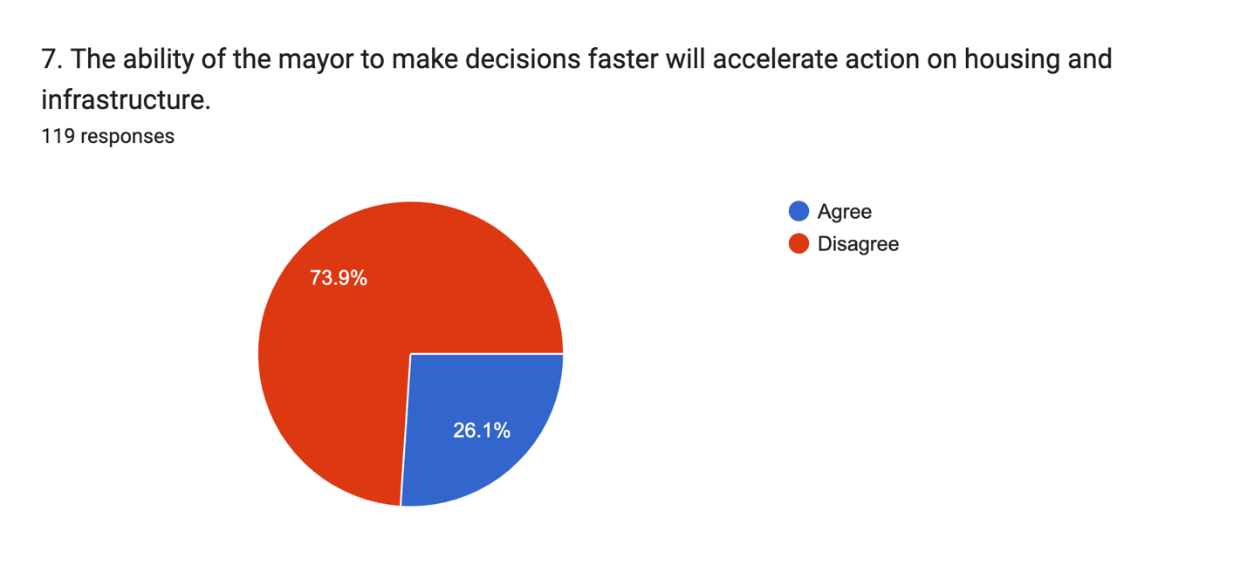

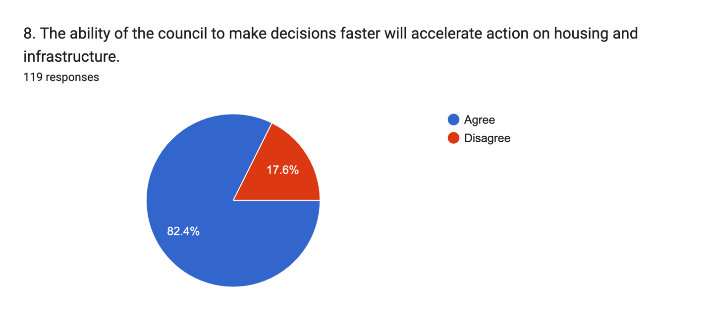

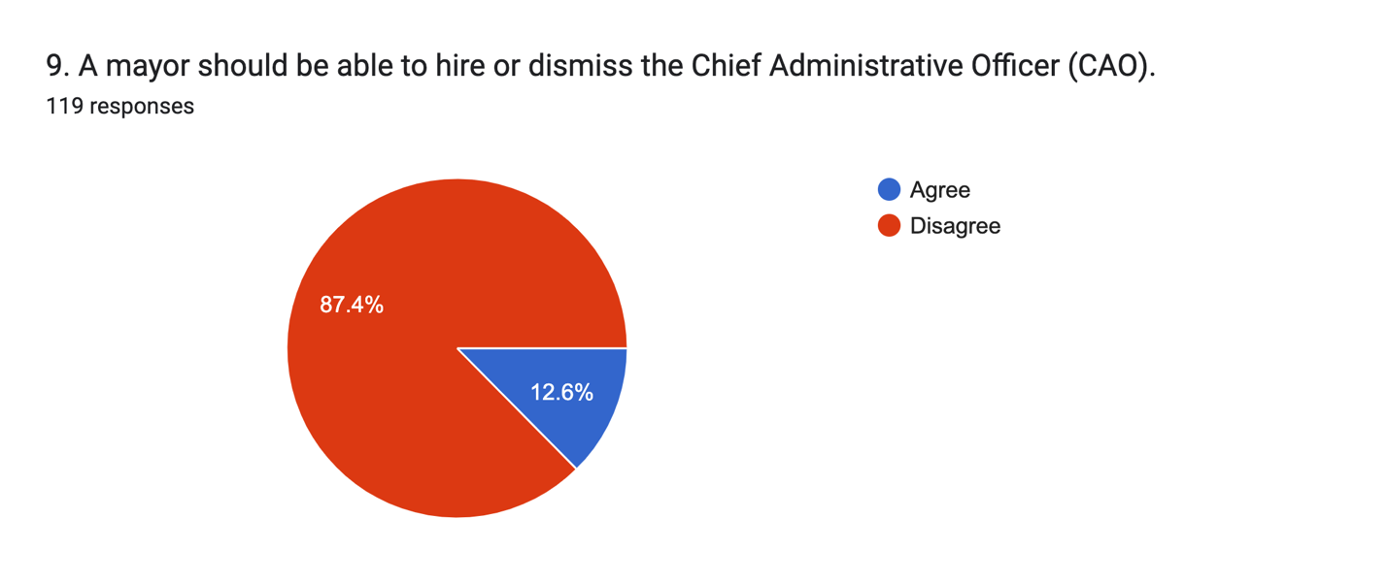
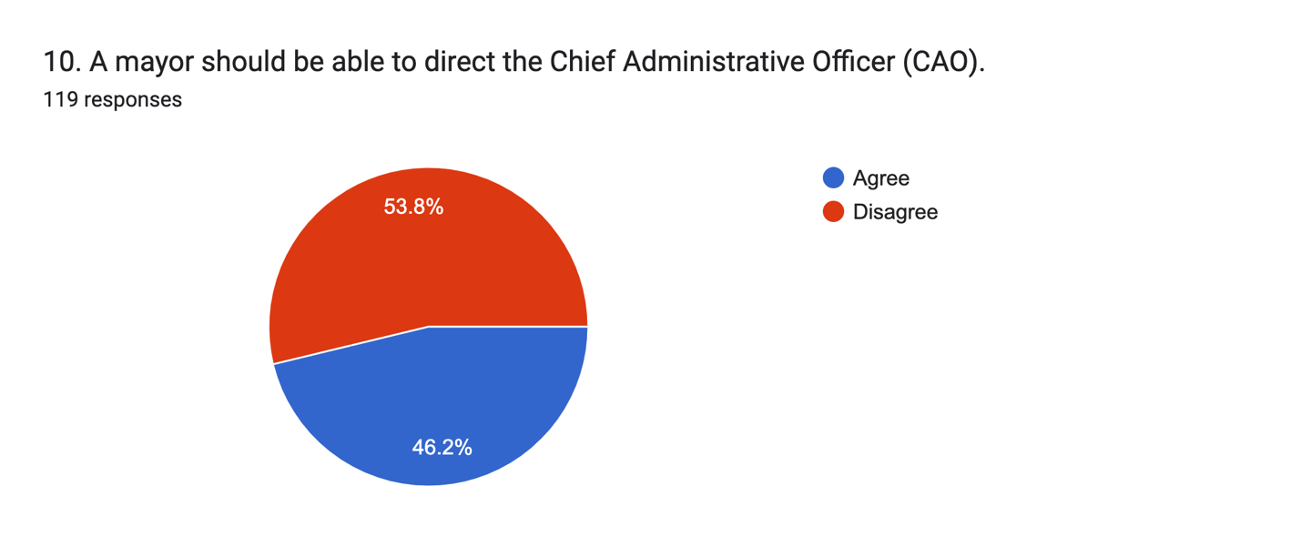
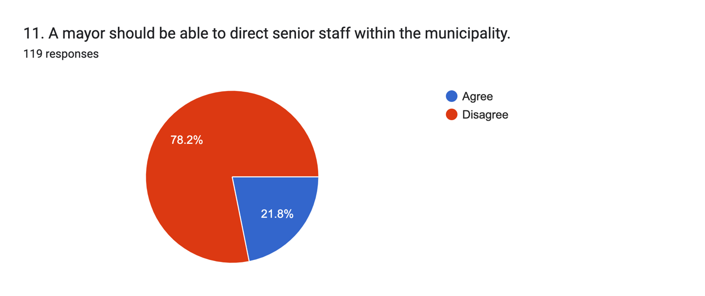

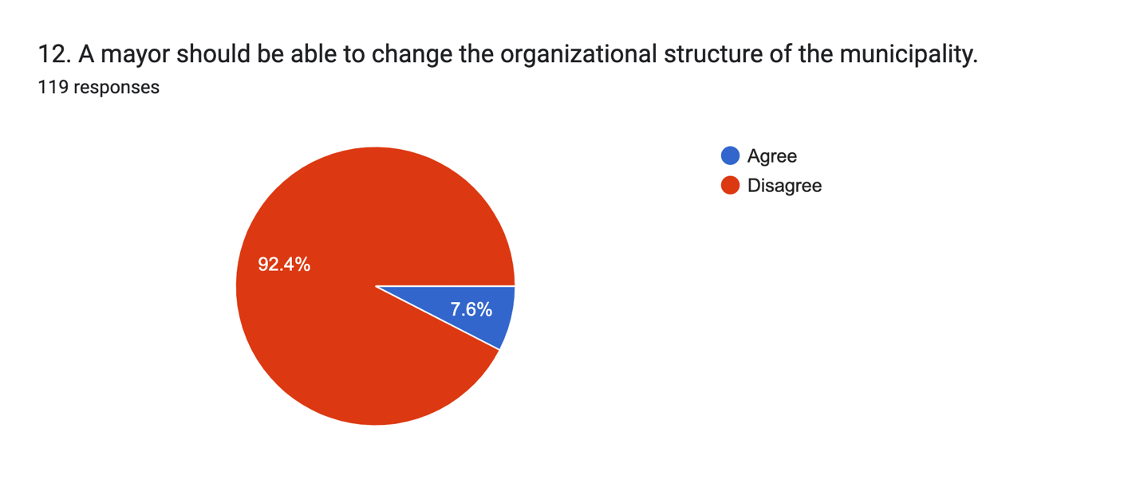

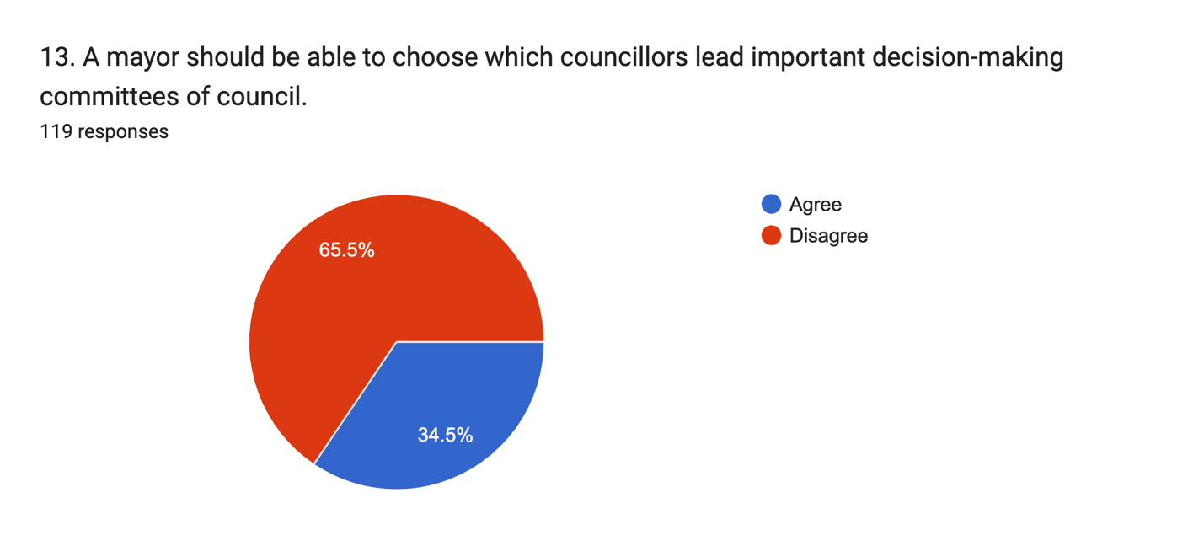
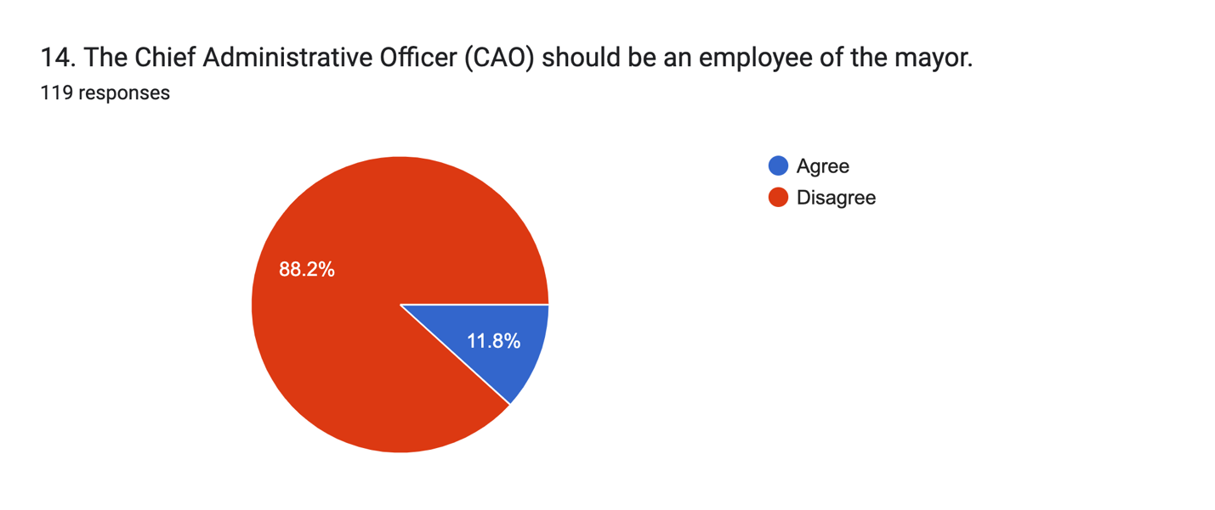

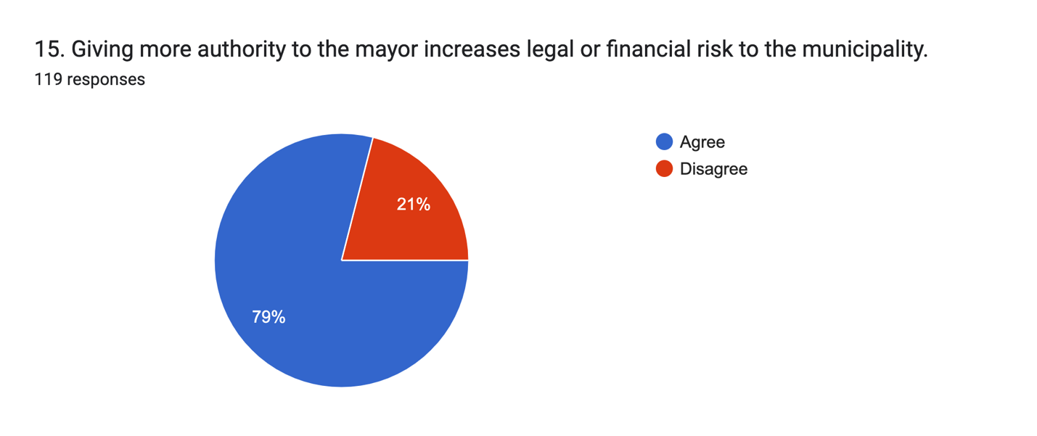

Check the statements you agree with
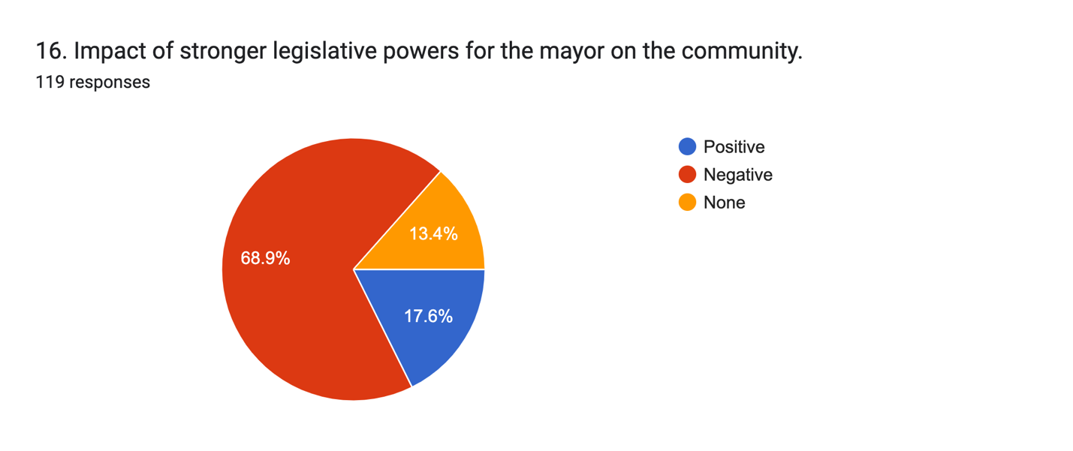
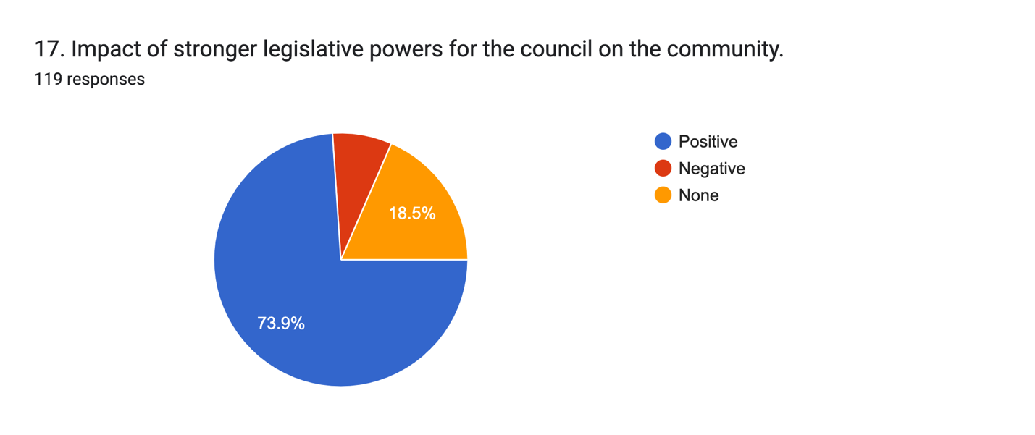

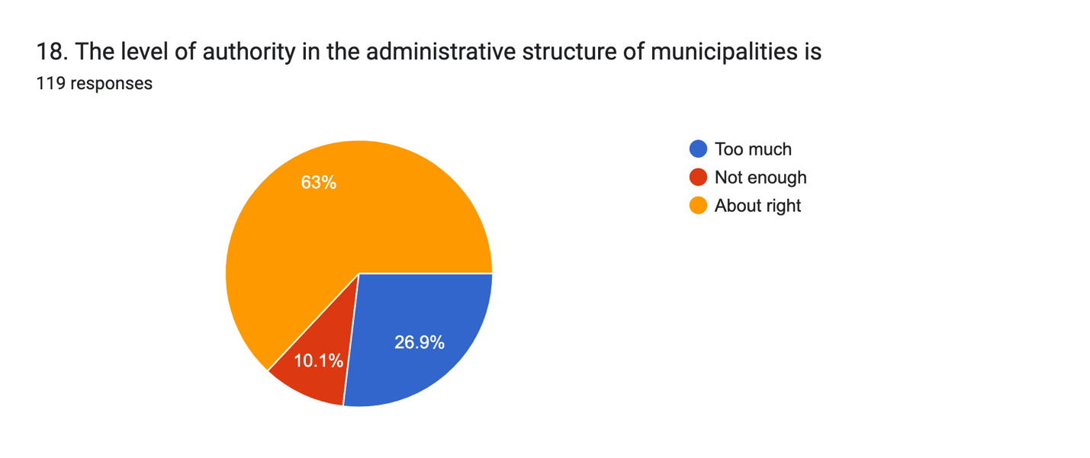
18 a. Any comments on this?
55 responses
no
Council as a whole tend to make more informed decisions as they have the thoughts and ideas of the group to draw from
It works well in our community
It’s critical to maintain the separation of political and administrative functions to ensure accountability, stability and non-partisan management of public services .
No
I do believe that Mayors should have some degree of executive powers, whatever those may be. Mayors should work closely with CAOs but only direct in a limited set of citations. We see continuously individuals with executive powers not needing the majority rule often gives into populism and fails to do what’s best for society at large but whatever the loudest group wants. Councils should have additional powers/authority to make more changes under the MGA rather than the small window of things they’re permitted to do.
The CAO can mislead or not provide complete information to Council which they may rely on to make decisions about the way they vote.
The province already has incredible overreach into housing and infrastructure (bill 329, changes to minimum planning requirements, 16 special planning areas, bill 24) - there is no way a strong mayor can advance housing and infrastructure beyond what the province is doing already.
The process of responding to a constituent’s issue is cumbersome; Council members should be able to approach department heads of Town directly
Senior Administrative staff are unelected. With absolute authority over staff and council it can often erode ability to prioritize projects and operational and human resource issues. They have little accountability yet if there is an issue the public and political fallout is borne by the Mayor and Council. If a CAO or Clerk has unacceptable work performance there is little mechanism and authority in place for the Mayor and/or designated Council to correct the inappropriate behaviour and take corrective action.
This answer comes down to trust and a positive working relationship. Council (as a body) must have the proper latitude to engage with staff and ensure information flows freely leading up to decisions on issues and in determining priorities.
It works right now. Council has overarching authority to spend money. Council has only one employee, the CAO.
The level of authority exercised in a municipality's administrative structure may vary depending on the personalities of the mayor and CAO and on the relationship between CAO and Council.
Accountability should be with elected officials ... The present structure I feel with the authority of staff making decisions . It falls back on the council if there isn't any backlash without Council having input and such instances.
These answers are all dependent on the context. What 'community' will be impacted? There will be winners and losers no matter what the province decides regarding Strong Mayor Powers.
Council ought to make some decisions without the need to defer for a staff report
Council as a whole set the priorities and govern. They are responsible to make sure the CAO makes their priorities happen. If Council or the Mayor starts being involved in daily operations- it will get messy. “Too many cooks in the kitchen”
n/a
There is a gap in knowledge for elected officials as many believe an unelected CAO is not accountable. This is wholly untrue as they are accountable to the mayor and council current day. Additionally, that knowledge gap exists when it comes to council and it's ability to fire a CAO which is very much within their purview and can and is done by municipalities today.
Yes, CAOs need to evaluate who they have in top jobs to make sure those people are executing the will of council effectively. Regarding question 16, it entirely depends on what they do with that power. Power can be used for positive or negative purposes.
Dysfunctional boards are a problem in any structure. A unanimous vote of Council should be able to call for a re-elect of Wardens (elected by Council), if duties are not performed as delegated.
What a BS survey . You are clearly bias in favor of 1 result . And clearly don’t understand what you are even talking about . How a more powerful mayor impacts a large city with a higher budget , and how it impacts a small municipality are 2 very different issues with 2 different sets of problems and results .
Taking the responsible away from council, who are the ones responsible to their residents.
Every Councillor was voted or acclaimed to make decisions best for their area and the Municipality
Need more info re Council questions don’t understand what you are getting at
In some municipalities the staff runs the show- so their recommendations rule decisions
No
The CAO and management team in our municipality are professional advisors to council and best suited to manage the municipality's operations and finances, at the direction of council.
There should not be Provincial overreach on matters of jurisdiction that pertain to the MGA
Stronger powers to the mayor minimizes the the whole reason to have council. If the mayor controls the whole organization and has a "Trump" agenda, it eliminates the voices of all the people.
Too much reliance on the CAO
I'm not exactly sure what the question is asking
Depending on the size of councils, rural vs urban, councils lead by the Mayor, not the CAO,should have more power. Too much decision making information is kept away from the Mayor & Council. This makes elected officials look out off touch, and downright foolish to the public.
Status quo...we all work together, have constructive conversations and pass motions with majority votes
Managing administrative authority is directly relational to the competency of council. Strong, representative councils, led by a collaborative community-minded mayor can properly balance tendencies toward administrative overreach.
We need to obtain the best and fearless advice from impartial staff. With the talk of strong mayor power, I am already seeing staff provide guarded advice as they retribution from the Mayor or his staff.
we have a very open staff that work well with council
The CAO has to much power to direct council and the mayor/ warden. In our area with a warden it should be a full time position and they make more than a part time mayor / warden who have the responsibility and accountability not the CAO.
Municipal councils were created as a product of the Provincial Gov. to handle the basic needs of communities as they now do. Yes things have been added on to councils responsibilities over the years but we are there to make sure residents basic services are met and these are individual to each community.
No.
no, but what is driving this question?
Elections selects candidates that people place trust to get things done. Staff don't always do the wishes of Council. They like to do their own agenda some times, finishing up the wishes of former Council. Council controls budgets, thus should have the ability to control actions of staff, but only if they are given the whole budget. Always an argument over operations and policy as both are interdependent of each other.
The Mayor should ultimately make decisions, not the CAO
The size of the community/municipality matters in this discussion. The HRM probably SHOULD have a strong mayor given its size, as governing "by committee" leads to stagnation and stalemate; however, smaller municipalities should not cede power to an individual because it dilutes the power of the council. IOW, in municipalities the size of the HRM, a robust campaign for mayor should be de rigueuer whereas in smaller communities the mayor is just someone to lead meetings, represent the municipality, etc. No special power need be designated.
It’s about right, though Council as a whole could potentially have greater input into some aspects that voters rely on, like communications.
I do feel the CAO needs to maintain the authority over staff. Councils change every four years so the CAO and staff need to maintain the continuity of a functioning municipality especially during the changeover Having said that council needs to make sure the CAO is accountable for the management of staff
Not enough. Council sets policy and strategic direction, but too often implementation drifts or stalls. The fix isn’t councillors directing staff—it’s stronger accountability of the CAO to council: clear motions with timelines, required implementation plans, regular public progress reporting/variance explanations, and tying CAO performance objectives to council direction. These tools would ensure staff execution aligns with council decisions.
It depends on the CAO and Senior Staff. In some municipalities, the CAO and Senior Staff are acting too much over in the lane of public process/ decision which should be occurring through the elected council. There should be greater role definition and legislative clarity between the roles of council and the CAO.
Politians need to be fully in control if their municipal progress.
There are many levels of power, with referential power being of the highest order. Position power is akin to brute force.
The CAO has too much power and can easily push their own ideas about what is important and let other initiatives fall by the wayside
Roles are well outlined in policies
none
The CIO would take direction from council.

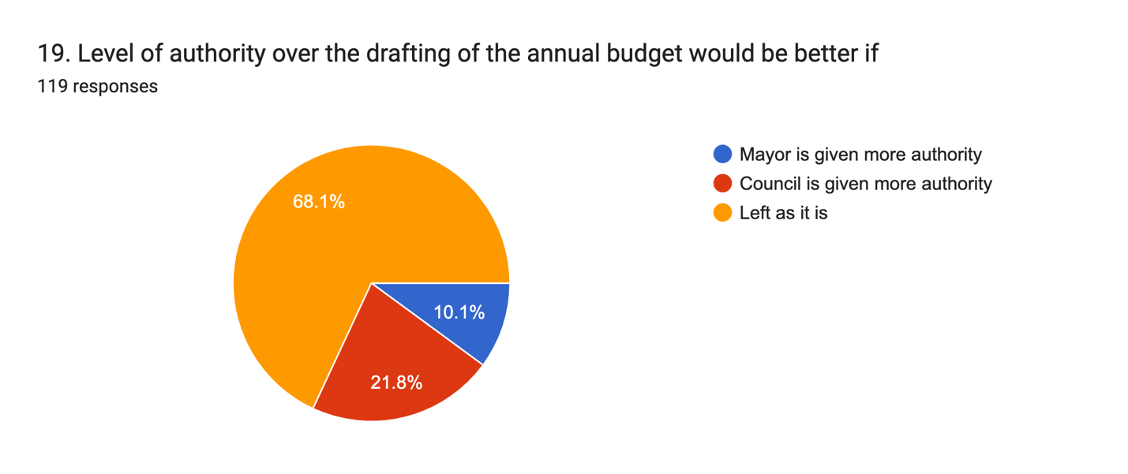
19 a. Additional comments?
34 responses
None
Council makes decisions based on staff recommendations - Very often there are amendments to the budget
The budget shouldn’t reflect the will of a single person rather than elected council. It deems elected council an inert body left to react to the mayor’s initiatives. What would the role of councillors become? How many would want to resign? This would cause a huge upheaval in municipalities.
None
I see no issue with the budget process being prepared by staff and handed over to council for review and revisions. Mayors have no need for additional powers and likely neither do councillors. Once handed over by staff with a budget baseline, they can make all the changes they’d like.
The CAO has complete authority about the type and amount of information provided to Councillors and Councillor’s access to that information. Councillors do not have access to relevant information to base a decision on unless it is provided to them.
A mayor has no need to advance a budget with strong mayor powers, when infrastructure is already being pushed forward with bill 24. Having a strong mayor over budget is an open invitation to nepotism, favoritism, etc. when services are the only levers available to a mayor to personally advance. Every cut or advancement of services will be viewed under the lens of who it benefits.
If the Mayor is proactive and there is full consultation with Council. The Mayor in my opinion should have more authority in drafting a budget with Administrative Staff.
There is often precious little actual descretionary money so Council priorities and strategic goals must be built into the budgeting process.
On our council, councillors only focus on what is good for their particular district and not what is good for the whole municipality.
This step towards strong powers for a mayor will lead to a diminished role for elected Councils and eventually their demise. The Mayor and the Minister will replace elected Municipal Councillors.
Electoral platforms can set the stage for mandate of the mayor
Council already has authority over the budget. CAO presents it based off of the legislative requirements, Council priorities, etc. Council can cut and add or direct staff to cut items to align with their priorities regarding service levels and tax rates, if that is what the majority wishes.
Having one person draft a budget without full council input is a massive risk and erodes transparency and public trust.
evidence based decision making needs to be prioritized. Staff need to bring issues forward to council rather than waiting to hear from us. We don't always know that something is a problem. Give us good information and let us decide.
I have often wondered what the point of your organization is , other to exists .
New and still learning this year seemed to go really well.
The council are the ones that are responsible to the residents. Council can be voted out.
Democracy is very important in Nova Scotia and Canada. Maybe the mayor should hear all the Municipality wishes instead part of it.
Same as above
Currently some municipalities are directed by staff not council
Earlier insight and influence over priorities would be beneficial overall
Answer in 18 a. applies
budget review and decisions needs more transparency
As a Mayor, I believe in stronger Mayor power but this needs to be balanced and only in certain circumstances. However, the CAO has far too much Authority. Much of the lack of transparency comes from what is kept from Council by the CAO.
We need objective advice from staff. We don't want service cuts in one district as the Councillor may have voted against a mayor's priority.
The CFO reports to the CAO not the mayor/warden which they should report to the warden/mayor
Council needs to get down in the budget, committee identify line items so that items are actioned as desired. If Council gives staff a blank cheque, their desires of action items may not match staff's and conflict will occur, power struggle. What residents want completed may not be what Staff action. Councillors are responsible and pay the consequences.
Council has the final say on approving the budget - that’s the ultimate control and can’t really be effectively added to.
CAO and management team work together to come up with their budgets which in turn must have the approval of council and Working with our CAO on our capital plan is the work of council
Council should have stronger input and oversight on the budget from the start. This is the community’s money, and councillors are elected to represent the public’s priorities. The mayor should not have more control than the rest of council in shaping it.
A democratic process of the full complement of council is how budgets should be drafted. The authority needs to be in the elected body as a whole.
none

20. What responsibilities do you believe the mayor should be accountable for in order to effectively deliver on their mandate?
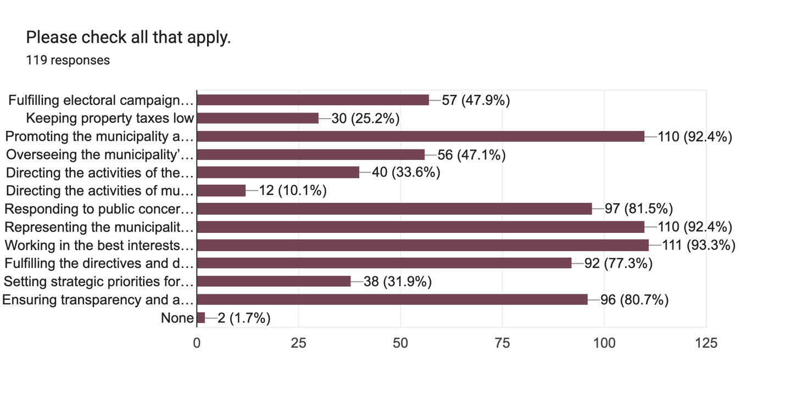

Comment Questions:
21. Specific areas of the Municipal Government Act that deal with the authority of the mayor, council, or the Chief Administrative Officer (CAO) that should be changed.
68 responses
None
none
The balance of power between the mayor and council should be minimized. Council should be involved in all decisions and kept informed of all issues, reports, plans and discussions involving the community. The role and responsibilities of the CAO should be more specific The process for appointing and removing key officials.
The mayor should have more authority to progress important projects for the municipality, set strategic goals and carry them out, veto powers over council decisions, and the ability to direct the CAO free from council over site.
Why would you change a council and Mayorwho are working together for the residents
I’m ok
no
I have no issue with a mayor being able to do more but overriding a major or super majority vote of council would be wrong. Many mayors are elected in small towns with little local media or serious opposition to keep them in check such as at the Federal or Provincial levels. Mayors can and perhaps should have more day-to-day responsibility or input not direct Council as a whole. Councils and CAOs should perhaps have their roles reverse. I like the structure where the CAO reports to Council and senior staff reports to the CAO. The mayor should absolutely NOT have authority to hire or dismiss a CAO alone, that’s a recipe for abuse. Council should have more authority through provincial legislation to do more in their community, for sure.
the interpretation of 30 (1), while the leg states comm directly between employees to obtain or provide information is permissible, ALL comm in our mun MUST go through the CAO for ALL information, and by email which is not only excessively bureaucratic which adds to workload and an attitude of not bothering to find out, it can lead to mistrust among staff and council and reluctance to share relevant info 30(3) the council’s suggestions, ideas and information should be encouraged and accepted in the manner it was given, the relationship between CAO and Council should be mutually beneficial and NOT hierarchial—-the fact that the COA is technically the employee of Council should not be required to repeat, call attention to or clarify 31 (b) timeliness is important and Council may feel no option but to agree to interim financial arrangements because the budget is not done in a timely manner—6 months late is not just inconvenient, there is real impact on taxpayers who rely on grants that are only available after full tax bill is paid meaning that taxpayers have to pay the first bill entirely and some taxpayers have difficulty doing just that 31 (2) the CAO does not need to attend all meetings of council committees and the “need to hear what is being said” does not justify having so many meetings to go to that other parts of the job, namely the budget, is delayed The CAO is not an elected position but an administrative one and the misunderstanding by many constituents that the CAO “runs the town and all decisions go through them alone” is concerning, clearly a part of the role of Councillors is to introduce and interpret the roles and responsibilities of municipal government
I think that the act should require greater collaboration between the municipality as a whole.
Yes
Section 15- Mayors or Wardens should include responsible to monitor CAO performance including hiring, training, assessment, assignment, performance evaluation, discipline up to and including dismissal. Section 16- Part 1 should be repealed and replaced with the Deputy Mayor should be an elected position for all Municipalities and not selected by Council. Section 23- Part c ( addition) Designated Council authority under Special Circumstances - dependent on a council members qualification, experience and ability may be designated by the Mayor and/or CAO to conduct Human Resources functions to assist in the operational governance of the Municipality including investigation, performance evaluation, hiring board, discipline board, providing evidence at GSB and or Civil proceedings.
Need more time to consider
Remove the Warden system and have the mayor elected at large.
Flexibility in taxation when proactively pursuing major economic growth opportunities
Yes, there are sections of the municipal government act that should be changed that allows for Council to have more input on day-to-day operations in a remote manner. Not necessarily dealing with day-to-day issues, but the voice of council should be heard.
It’s rather basic. Perhaps more authority to direct the CAO on certain initiatives without waiting for staff reports.
N/A
I don`t feel these really needs much change on the whole.
Things are alright as they are now. For the town that i live in
Not sure
Sometimes it’s hard to know where council’s job ends and the CAO’s job begins. It would help to have a better balance and maybe a little more say for council in making sure things are being followed through properly. Also, it would be good if the Act made it more clear that the mayor and council need to work together, not separately.
The Municipal Government Act is being designed to strip power from council
We are in the 21 century, meetings can happen within days or important events, hours, let the whole council have a vote.
More Mayoral powers on infrastructure planning transit community connectivity traffic
I don’t feel I do have enough knowledge as it relates to the MGA to suggest changes
Just change the outdated MGA rules that no longer apply in 2025. This will speed processes up.
no they are fine the way they are now
No
Left as is
any that improves efficiencies in implementing council's direction
Stronger Mayor power, less authority for CAO
Amend Section 36 to require council approval for significant decisions made by the CAO — such as senior staffing, large procurement contracts, or policy implementation frameworks. Introduce clearer provisions for regular reporting from the CAO to council on administrative and financial matters. Clarify that the CAO is accountable to the entire council, not just to the mayor or warden (as per Section 30(2)), ensuring all elected officials have equal oversight. These changes would promote transparency, reinforce council’s strategic leadership role, and ensure administrative decisions reflect the will of the elected body.
Clarity specifically the roles of Committees. In my one year experience, Committee work can violate the CAO model.
CAO's authority to act needs curbs
CAO authority or right to attend any meeting of Council that they choose should be removed.
yes
I think the current system of checks and balances works. If there are to be role changes, these should be implemented for the next election cycle.
THE CAO must report to the mayor/warden, it is essential! They have the accountability and responsibility not the CAO
No
nil
Nonex
Why change it? It's working fine as is.
It is clear, sometimes the interpretation of rules are disputed.
Address the issue of communities of size, HRM & CBRM.
I strongly feel that it should be left as it is.
The MGA should be amended to be crystal clear about exactly when and how municipal governance can be changed. Major changes should be done by public referendum, and changes should only be done in alignment with the election cycle. For example, no one in HRM voted for a mayoral candidate based on their ability to implement Strong Mayor powers. Providing those powers in the middle of a term essentially voids the votes of HRM voters - there are several HRM councillors who received more votes than the current mayor meaning he has less of a mandate from voters than those councillors.
The MGA should be updated to give council more effective tools to hold the CAO accountable, especially when there are performance issues or a toxic work environment. Right now, the CAO is council’s only employee, but the options for addressing problems are limited to dismissal, which is a major and often divisive step. There should be a clear process for raising concerns, requiring action, and protecting the wellness of the municipality as a whole, including staff. The MGA should also allow council to request independent audits or third-party reviews when there are serious concerns about implementation, workplace culture, or public trust. These should be available without having to rely solely on the CAO to initiate them. Minimum standards for public engagement should be set in legislation for major policy changes, budget decisions, and large-scale projects. Residents deserve to be consulted meaningfully, and results should be made public before decisions are made. These kinds of changes would support accountability, transparency, and good governance while keeping the balance between political leadership and administrative operations.
I think the power should reside with council and the mayor as one team/ elected entity. I think the CAO’s powers should be limited to providing thorough and objective information upon which those elected should be responsible and authoritative in making the decisions. A CAO should be able to make recommendations based on the information provided, but the sole authority for making the decisions should rest with the majority vote of those elected to govern.
Changes that mirror Ontario's legislation
Hours of valuable time are wasted annually dealing with unsightly premises. There need to be incremental tools so that unsightly premise issues do not take years and years to remedy. The public needs municipalities to deal effectively with these issues as they arise so that they don't have to die before these are remedied.
No specific examples
-
Keep the same
At this point in time, I think the MGA addresses the responsibilities of both the mayor and the electric Council. At no time do I believe that a mayor should be able to veto or override a council decision.

22. Provide examples where you feel enhanced legislative powers for the mayor would be beneficial.
77 responses
None
none
n/a
It would improve efficiency by streamlining decision-making and avoiding lengthy debate
It could streamline decision making and move critical projects forward
Seeprevious question
When personal agendas come into play
Responsibilty for bringing priorities to the elected council.
Fast tracking building and planning permits
Only in emergency circumstances
None!
None.
Uncertain
None - all important decisions that affect the community should be made by council, not the mayor alone
Noted in previous answer. Additional Mayoral authority would assist in governance of municipalities especially smaller municipalities. It will assist in reducing bureaucracy and expediting priority projects and initiatives.
In emergency situations, in areas that evidence supports that stalemates are the result of strategic bias.
Setting the five year capital plan. Right now our council is deadlocked and we do not have any new or emerging capital projects on years 3, 4 and 5 of our capital budget due to the parochial nature of our council composition.
Unsure if any Mayor's need enhanced powers
I don't feel enhancing the powers of the mayor would be beneficial
Having a second vote to break ties. Political platform can set some of the priorities of the Council strategic plan
N/A
Never
Someone needs to be in charge and the upfront person.
It would be beneficial in some daily activaties of the town employies
Removal of underperforming councilors from committees. Preventing councillors from attending conferences if they are going just for a vacation. Beyond that, no extra are needed.
In an emergency, it could be helpful if the mayor had a bit more power to make quick decisions without needing to wait for a full council meeting. Things like storms, flooding, or any kind of urgent situation come to mind. Also, when the mayor is trying to get funding or support from other levels of government, a bit more authority might help speed things along and make it easier to speak on behalf of the whole municipality.
in emergence , storms, fire, floods, etc.
Only in extordary circumstances but only with experts advice
Housing, transit, infrastructure, emergency preparedness, community connectivity
NONE
None that I can think of
Overturning a desicion of council where a loud small minority impacts council desicion and strategic plans
There isn’t any
They shouldn’t
None. This is a tremendously slippery slope, and date from Ontario does not bear out results that warrant this consolidation of power. Any powers that rest with the POSITION is risky given who might be the next mayor, and any power that rests with the PERSON smacks of politics.
Never
timeliness for the implementation of council direction
Currently, It is too cut and dry, there could be more flexibility with roles, more working together of Council and Staff. In controversial situations the Mayor should have more authority, in emergencies and urgent matters the Mayor should be informed and have some decision making power. Upper management hiring.Financial with guidance/ oversight from the finance committee
Emergency Situations: Allow quicker decision-making during crises (e.g. hurricanes, wildfires, health emergencies). Example: Mayors in larger cities like Toronto acted swiftly during COVID-19 under emergency powers. Strategic Project Implementation: Enable the mayor to more effectively advance council-approved priorities (e.g. housing, infrastructure) without administrative delays. Example: Toronto’s “strong mayor” powers supported faster action on housing targets. Intergovernmental Representation: Strengthen the mayor’s ability to represent the municipality in funding or policy negotiations. Example: Mayors in cities like Calgary and Vancouver have led major funding agreements. Caution: Any enhanced powers must be clearly tied to the municipality’s strategic plan as approved by council, with built-in checks and reporting to maintain transparency and uphold democratic accountability.
Develop and maintain safe, viable communities, work with neighbouring communities,
If it helps moves business forward that can beat service the community. Allow for impact on the greater good that might be held up by the individual beliefs of Council
If a mayor feels strongly and has experience ie firefighting. a facility for training vote should be able to be overturned by the mayor
I would be comfortable with the mayor having the authority to break a tied vote.
She/he has the responsibility and accountability to get it done not the CAO. Quicker decisions, Know the pulse of the residents and must to be full time you can’t do it part time
nil
Dealing with public concerns
Inappropriate Council responses to special interest groups.
Mayors are responsible for the whole municipality, whereas councilors are responsible for their wards or districts. Mayor should have veto type powers to stop councilors from teaming up to enhance their own agendas should they make deals with each other.
Dealing with priorities that come up suddenly and need a quick, decisive decision
Only communities of size need a more structured model for reasons I already described. In Nova Scotia, that would probably be the HRM and the CBRM.
I do not feel that strong mayor powers would be beneficial.
I can’t - I do not believe it to be beneficial for democracy.
I do not see a benefit to enhance the powers for mayors
The only situations where I see value would be in very limited, clearly defined circumstances — for example, acting as a tie-breaker in an administrative or procedural vote, or in cases where council has agreed to temporarily delegate a specific responsibility to the mayor for a set period of time. These powers should always be granted by council, with the ability to revoke them at any time.
Emergency situations which may require a more expeditious decision-making process for the sake of public health and safety.
Changes that mirror Ontario's changes
I can't think of a single area. If a mayor uses referential power, which is the highest order of power, they can get things done effectively with and through people.
No specific examples
If the Mayor works from the direction of council and the priorities established.
In lower level finance decisions
Emergencies, evacuation orders

23. Provide examples where you feel enhanced legislative powers for the mayor would be harmful.
82 responses
One of the great strengthes of municipal government is the impartial civil service. If the CAO and senior staff report directly to the Mayor and not Council, they become an arm of one person. That would weaken evidence-based decision making and open the door to corruption.
Almost always -
There would likely be less transparency and accountability. It might appear to undermine the democratic process.It would minimize the role of council.
Undermines the democratic process. Would fundamentally change the landscape of municipalities . Many councillors would likely resign as they see a role that lacks any impact.
there would need to be a mechanism where someone could override a mayor Decision if it was completely out of touch with the public’s opinion.
If the mayor is refusing to work with council
Making unilateral decisions without a democratic vote of elected officials.
Carrying out personal agendas
Reduce transparency and allow too much power to be concentrated
- Hiring and firing a CAO at will - Overruling council for decisions that are politically beneficial to them alone compared to council making the best decision at large - Vetoing projects that they don’t agree with but the rest of council does. - Financial abuse due to less oversight - Directing senior staff in direct contradiction of the CAO
The Mayor currently has agreed to changes to the compensation and working conditions of municipal staff without any discussion with Council, I am not sure that this is permisssable now but if this was allowed the elected officials to manage the financial health of the municipality become more limitd
Given the position of the province, the only outcomes for a municipality with a strong mayor would be negative. Again, the province has all the legislative tools they need to expedite housing and infrastructure in HRM. Anything beyond that is not just unnecessary, it will undermine public trust in council, erode collaborative governance, and introduce division where unity is needed.
going against the will of Council after a decision has been made. Council is not an advisory board to the Mayor.
The Mayor should not have absolute power, there must be mechanisms and record of meaningful consultation with Council and CAO. All issues, projects and initiatives introduced shall be presented to Council for discussion prior to any approval.
When an overwhelming majority of council are against a decision .
Any decision left in the hands of a single person is ripe with risk of bias and self interest for the Mayor and legal liability for the municipality. Councillors would become useless
Overriding council wishes on setting the tax rate.
Overruling or vetoing councils majority decisions. financial decisions that could drive a municipality into debt against the councils wished.
Being able to veto the majority vote of Council. Being able to fire the CAO without agreement of Council
Too much legislative power in any one person's hands is not productive and can be harmful in certain situations
Overturning any majority vote if council that has 2/3 support.
A majority vote builds consensus on an item, often lands at a compromise and is just good governance. Enhanced legislative powers erodes all of that, is not good governance and is not what Nova Scotians voted for in the municipal election in 2024.
never
I feel if the powers were enhanced more it could cause greater conflict as the Mayors wouldn`t need to be accountable to Council on much.
The answer to this question and most of the other ones.would depend on the intensions of the mayor. It's not good to take away to much of council input .
Additional budget powers, ability to hire or fire staff, additional voting weight, all would be harmful. If the mayor can just fire a CAO without cause on their own, the financial implications of a payout by the municipality could be huge.
all mentioned in survey
Giving too much power to one person, even the mayor, can really throw off the balance. In small communities like ours, decisions work best when council talks things through and works as a team. If the mayor had too much say without needing council’s input, it could lead to decisions that don’t reflect what the community wants. It might also cause division and make council feel like their voices don’t matter. That can hurt trust and how well we all work together.
Concentration of authority in the mayor's office, particularly in situations where council's role in decision making may be bypassed or diminished. If the mayor can override or ignore council's wishes, it undermines the democratic process and weakens the role of elected representatives. When decision making becomes less transparent and inclusive, residents may feel excluded from the process and perceive governance as less legitimate
Big emergencies, but only for a particular area of the Municipality
Over rule the majority of council on affordable housing
Should still be checked by province for final decision-making
To much control
Hiring and firing of senior staff compromises their ability to deliver impartial advice and therein negatively impacts council’s ability to make evidence-based decisions, politicizing municipal governance to a degree that we are fortunate to avoid with our current structure.
Undemocratic. Greater risk of abuse. Greater risk of error. May cause delays if the person with strong mayors’ powers is against something moving forward.
On principle, enhanced mayoral legislative powers could have a real effect of degrading the integrity of an elected council.
None
Needs to be a majority vote to pass. Mayor vote counts as one vote.
Having the Mayor over reach council
When the mayor is part of the vocal minority caused by apathy of voters during an election
It all would be harmful
The ability to hire and fire staff, the ability to over rule council when they have gone through a transparent public process to reach a decision, a less than congenial relationship between mayor and council, also it could lead to a lack of good community minded people willing to run for and serve on council as it could be seen as a waste of time if decision making is skewed to the mayors office
If a motion was passed that they disagree with.
Council would never know the direction of the Municipality, and it would be difficult to update and be transparent with constituents
See above.
directly opposing council direction, managing staff
Almost every situation you can imagine
Hiring of all staff, directing all staff, the budget
Undermining Council’s Role: Giving the mayor unilateral authority to advance or veto initiatives could weaken the democratic process and marginalize councillors, who represent diverse community voices. Reduced Transparency and Accountability: Concentrating power in the mayor’s office may lead to decisions being made without full public debate or council oversight, reducing transparency in governance. Risk of Politicization of Administration: Enhanced powers might allow a mayor to influence administrative decisions or staffing, potentially compromising the neutrality of the CAO and municipal staff. Disruption of Collaborative Governance: Nova Scotia municipalities typically function through consensus and teamwork. A shift to a "strong mayor" model could create tension, diminish collaboration, and polarize decision-making. Inconsistency with Local Government Scale: Most Nova Scotia municipalities are small to mid-sized. Strong mayor powers may not suit this context, where local issues benefit from collective decision-making rather than centralized authority. Summary: While efficiency is important, enhancing mayoral powers without strong checks and balances risks weakening local democracy, sidelining council, and reducing public trust in municipal governance.
If the mayor has certain personal agenda that they would like to incorporate into the decision making process, that would not be a good thing. Council is there to decide alongside the mayor.
Directing staff
Overruling decisions of Council
Overriding council’s decisions, directing the CAO, directing staff,
Inter provincial matters
Anytime the powers of the Mayor office are used to promote a self serving interest instead of the greater good for the community.
Removing democratic decision making by majority control of Council
if they went against the majority wishes or vote of the council
Acting on his own too much. this loosing a team concept with council members
The mayor may circumvent the views of council who represent their districts needs and decide to place a construction debris facility in the district of a councillor he does not agree with. He may decide to approve projects that are damaging to the environment to support his or her friends. We need a municipal lobbyist registry to provide enhanced transparency.
I He/she will gets tossed out by the electorate in the next election.
having no one to check on his or hers decision making
Why have the residents vote in councillors if the mayor is going to do what they want . councillors are just that councillors for teh municipality. People to discuss decisions with and to have input and new ideas.
None
many of the suggestions in part 1 of this series
A good working Council is a democracy. Allowing the Mayor the right to veto a Council Decision, would be harmful.
Mayor overrules the will of Council when a clear majority is present. A minimal majority (5-4, or 3-2) may not represent the wishes of residents
Hiring and firing
All the other municipalities, given that their councils tend to be smaller and enhanced powers dilutes the power of councils.
There are too many to list and that is being proven as we speak in areas where strong mayor powers are in effect.
Every example that isolates power to a single source is harmful to democracy and good governance practices.
I think this is a stepping stone for doing away with municipal governments. If the enhanced powers are given to mayors, councillors are redundant
Allowing the mayor to pass motions without majority council support would make council votes meaningless and silence residents’ voices. A veto over council-approved decisions would override the representation residents have through their councillors. Authority to hire, fire, or direct the CAO and staff could politicize the municipal administration, damage trust, and undermine the neutrality of staff. The ability to restructure the municipality without council approval could sideline community priorities and reduce accountability. A mayor with expanded powers could also be more easily influenced by higher levels of government, prioritizing funding relationships over the needs and voices of residents. Councils are the grassroots — elected to represent their communities first and foremost — and these powers risk shifting that focus away from the people we serve.
On any matters financial or any matter related to what could otherwise be dealt with by the full complement of council.
It would put party politics back in Council Chambers and beyond
I have seen it happen many times over my long career, where Council is forced or coerced into following the will of a bully who does not have the best interest of the community at heart, but their own selfish interests, either financial or to acquire more power. In this province, it is possible to owe money to your municipality for years in unpaid taxes or water charges, and be a Councillor or Mayor. It is only in the lead-up to elections that you are required to be free of such bills. There is a very good reason for this: financial difficulties are often a predictor of other larger issues.
I feel we would lose a high degree of transparency. Collaboration is really important and the views of all those around the decision making table are important and need to be heard. Enhanced legislative powers would open the door for corruption and personal agendas and favouritism.
All areas
No specific examples
When the Mayor acts on their own interests and not that of the Municipality or council.
Silo effect more council voices the better
Taken advantage of in cases where the Mayor feels they are a sole arbiter
At no time should the mayor have authority over municipal staff, over the final decisions on the financing, the budget or overruling the elected council

24. Provide examples where you feel enhanced legislative powers for the council would be beneficial.
74 responses
none
None
No idea - what enhancements?
It would enable more efficient responses to needs and priorities of the community. It would help reduce having to rely on provincial approval for important and timely issues.
More efficient decision making. Could initiate a bylaw or specific policy review. Could drive their own agenda.
Only under the direction of what is beneficial for the residents. No time for personal agendas
Moving projects along
It's functional now
Council usually has a variety of persons from different genders, experiences, education and knowledge and ideas that can benefit the decision making process.
none.
It would provide more efficient timeframes to answer constituents’ concerns
Assist in governance and operations of smaller, cash strapped municipalities. Untapped resources and in individual councillor experience and qualifications could greatly benefit the overall community.
Not all municipalities are the same geographically or financially.
Not sure what is being suggested by the question, the Council vs the Council and Mayor or as a collective??
We have enough legislative powers at the present time.
Economic Opportunities.
Fewer directives from the Province
To have more authority when it comes to dealing with municipal operations and have a voice in some of those. There needs to be a division between elected and administrative jobs but having input as an elected official on many issues that a council doesn't have now would be more productive
We ought to have sone authority on reviewing service standards and contract agreements
Being able to properly protect the coastline since the CPA was abandoned. Currently we do not have the power to put teeth in our land use bylaws to stop things like shore armouring etc as it is outside of our jurisdiction
Whenever action is immediately required
I feel given the chance Council could be more beneficial as a group, not just 1 person making the discussions.
I don't see any big benefits
Not sure
I'm not sure, but perhaps more department heads should report to council than just the CAO. I am concerned that the actions of some staff do not reflect the will of council and staff reports are lacking key holistic information on topics and how decisions affect the long-term finances of the municipality are missing.
Council as a whole including the Mayor as one vote should make decisions.
When council is on the same page and working together, having a bit more power could help move things forward faster. Sometimes we get slowed down by process, even when we all agree and are trying to get something done for the community. It could also help us keep things on track if we had a little more ability to follow up on decisions and make sure they’re being acted on. That’s especially important when we’re backing something residents have asked for.
Control the number of staff being hired to ensure efficiency and cost effectiveness. Improve communication with staff to promote clarity, teamwork, and alignment. strengthen Councils authority so that staff view council's guidance with greater respect and importance.
Regional emergencies that will affect the whole Municipality or life and death Regional emergencies
Lowering taxes
Community connectivity, strategic infrastructure planning, emergency preparedness
Council represents the constituents
Council members and the Mayor already stand up for their specific communities wants, needs and concerns. Please get rid of unnecessary red tape while still protecting the environment. Processes that take many years to implement for Provincial and Federal support need to come through faster so they do not flip back every time there is a change in government. People want to see shovels in the ground. Roads, deer population, business development, the housing crisis, policing, water supply and revitalization of rural communities are all not new concerns. Opportunities in sustainable farming and the construction trades to keep our young people at home in rural Nova Scotia are key. Our powerful neighbours are no long allies .
it would allow council to be quicker approving important items
It’s fine the way it is
I am unsure what is meant by advanced legislative powers for council - if the province restored what they have taken it would be a start. I believe that municipal government should be a fully free standing level of government not controlled by the province.
Taxes
I feel council working together in the format that is current today works.
I think Council should have more flexibility in matters related to housing. E.g., the authority to reduce property tax where developers are building affordable housing.
budget approval
More powers over taxation, fees, traffic speeds and enforcement (MVA), watercourse alteration, and many other areas would be helpful to municipalities.
Upper management hiring, receiving information prior to issuing of permits/ development agreements which may be controversial, (what is in the hopper). Councils must be able to meet without the presence of the CAO, it is rediculous that members of councils can't gather or meet to discuss anything, how do you develop mentorships, know the people you work with. Politics is lonely, we handle much that is confidential, one needs to be able to get support from their colleagues.The perimeters around Council relationships is inhumane and sets up Council members for burnout, mental health issues and a very lonely 4 years.
Oversight of the CAO: Council should have greater authority to review or approve key administrative decisions made by the CAO, particularly related to staffing, procurement, and policy implementation, ensuring alignment with council’s intent. Budget Control and Reallocations: Council should have enhanced flexibility to amend or reallocate budget items throughout the year without excessive administrative barriers, allowing for more responsive financial management. Accountability for Strategic Plan Execution: Council needs stronger tools to monitor and enforce progress on its approved strategic plan, including mandatory reporting from staff and clearer authority to adjust priorities as needed. Transparency in Major Contracts and Projects: Council should have the legislative power to review and approve significant contracts or capital projects before execution, increasing transparency and public trust. Policy and By-law Development: Individual councillors should have more defined authority to initiate policy proposals or request staff reports without requiring full council approval at the outset, supporting a more responsive and innovative legislative process. These enhancements would reinforce council’s central role as the community’s elected decision-making body, while still respecting the administrative authority of the CAO under Nova Scotia’s Municipal Government Act.
If council is made up of a diverse group of folks that have the well-being of the community they are in as their priority, then it would be beneficial if they had enhanced Legislative powers.
Get work completed faster,
Inter provincial matters
More involvement and control over project administration
if they are carrying out the wishes of the majority of their constituents
Currently the Councilors share a staff support person that is able to support the Councillors with calendar management, management of district capital funds and follow up with staff on resident requests. The mayor's office has four soon to be five staff which provide strategic political advice. Perhaps the role of the Council Support Office should be modified to align better with the role of Mayor's Office employees.
We cannot talk to staff unless we go through the CAO we will get quicker resonse
i think council has enough power at this time to look after his or her constituents.
the powers would need to be specified for me to answer this
More voices none
I see no benefits to enhanced legislative powers for the Council.
Overrule the CAO to ensure staff do the wishes of Council
Directing senior staff
No changes needed.
In every example it is most prudent to have strong powers for council. That is proven good and most effective governance.
Council potentially having greater input over management of all senior level staff could be helpful.
Council needs to be able to make decisions that work for their area. The province should not have the authority to overrule a council decision. We need to be equal voices at the table with the province
Council could be more effective if it had stronger tools to follow up on its own decisions. This would mean being able to ensure that when motions are passed, they are implemented as intended and within a reasonable timeframe. A greater role in shaping the annual budget from the start would make sure priorities reflect the needs of all communities, including rural areas, rather than being influenced too heavily by one office. Council should also have the ability to initiate independent reviews or audits when there are concerns about the way projects are being delivered or how public funds are being used. This would add an important layer of accountability.
Most legislative power should rest with the majority votes of the elected body (Council)
Speed of decision making.
I mentioned the management of unsightly premises earlier.
Don’t change
No specific examples
More transparency.
Emo
Tax exemptions for growth, more responsibility for local issues that don't affect the province one way or the other (for goodness sake, permission for a "no parking" sign? Ludicrous
None at this time none of this time

25. Provide examples where you feel enhanced legislative powers for the council would be harmful.
65 responses
None
n/a
Cannot think of any
It might lead to hasty decisions and cause further power imbalances between council and mayor and staff.
Some may prioritize their own projects over the wellbeing of the greater municipality, particularly where it is large.
none
If your Mayor allowed personal agendas to take control of the agenda
Democracy depends on debate and a voting process by elected representatives.
Discouraging staff
It's functional now
none.
Getting directly involved in contravening collective bargaining…either accedentally or purposefully.
Should not be used regularly but only in special circumstances. Deputy Mayor and Council shall not supersede the authority of CAO or Mayor. Not to interfere with daily operations and give operational staff direction. Do not want overeach.
See above
We are going to spend $7.5 million to hook up 30 homes with water and sewer. This is a total waste of precious funding from the three levels of government and it will actually be a negative impact on both the water and sewer utilities. The only reason this is moving forward is it is in the Warden’s district with the support of a majority of council.
Unsure.
Council moving to direct staff, not through the CAO
As long as it can be done by way of a majority vote of counsel I see that there would be no reason to enhance legislative powers
Not following the advice of the Auditor General
Uncertain
When not an emergency
Within the town offices, if given more power some council may feel entitled to being able to direct the administration staff.
I don't think there would be
Not Sure but they should not ever be allowed to direct staff outside a council meeting.
same answer as last question
If council had too much power without the right checks, it could get messy. You might end up with councillors getting involved in day to day operations or trying to direct staff, which isn’t our role. That can create confusion or slow things down. It’s important that we stick to our job as decision-makers and leave the running of the day to day stuff to staff. Too much power could also lead to decisions being made based on politics or pressure instead of what’s best for the whole community.
That they could get to much involved with the day to day operation with the staff
Regional emergencies
Lower taxes when the budget cannot afford it
Ideological pet projects
non that i can think of
Any decision under a provincial or federal pervu without the budget to enact them aka costal protection act
special powers for anyone makes it hard for council to work together. Good team work makes good governing decisions!!!!
directing staff
Directing staff, setting the meeting agendas
While strong council oversight is important, expanding legislative powers without clear boundaries or respect for the CAO’s role could reduce efficiency, politicize operations, and harm effective governance. Slower Decision-Making: Requiring full council approval for more operational or routine matters could create bottlenecks, delaying service delivery and reducing responsiveness to community needs. Increased Risk of Gridlock or Division: In councils with strong opposing views or political factions, broader powers could lead to deadlock, undermining effective governance and eroding public confidence. Reduced Accountability Clarity: If council holds expanded powers without clear boundaries, it can be harder to determine responsibility when things go wrong — blurring lines between political and administrative accountability.
Directing staff , getting into operations
Interfere with staff
taking matters to legislation that they thing is more important to themselves rather than that of the people they represent
I am not advocating for enhanced powers.
If you have councillors able to freely ask questions and not through thCAO we would be better off
if council have too much power i believe 1 bad apple in council can be harmful to decision making.
refer above
None
see comments in the first set of questions.
The Council must work jointly with the Mayor. Giving Council additional powers may change that dynamic resulting in a negative impact.
Could impact the organization of staff (Council like a staff member over another, like to work with that staff and not another) could disrupt the operations
Pushing their own personal agenda when some councillors would’ve received less than 50% of the vite
HRM and CBRM council issues are substantial, leading to gridlock and stagnation.
If decisions are being made by any council, they are majority decisions and are the best way to achieve good governance. Strong mayor powers would not achieve this.
Having greater authority could slow down operations.
I do not see any harms to having a stronger voice through the municipal governments we need to stop being treated as creatures of the province
In emergency situations where expeditious decision-making is necessary and, if not done, may be harmful to public health and safety.
I think that empowerment is generally a better approach than being considered a creature of the Province. That is an old-fashioned concept that does not serve the public. Municipalities represent the level of government that is closest to the people. Services are largely delivered through them and/or in them, and as someone once said, "everything that happens happens within a municipality".
All area
No specific examples
Too much involvement in daily operations and direct dealings with staff.
Too many local ordnances of no real value
None of this time

26. Other ideas on changes to processes that would support good governance and responsible decision making in your municipality.
63 responses
None
none
In general, municipal governments should be empowered to work more broadly in local matters. Natural persons powers and more delegated spheres of authority rather than the exhaustive and inefficient approach of listing everything that municipalities can do would be better.
Improving public engagement/consultation processes; adopting a clear and concise asset management plan would help in all aspects of decision-making and progress in the community
More opportunity for public engagement in the community other than town hall. Find ways to attract younger candidates and those that work full time such as streamlining meetings, allowing for remote participation. Mentorship programs to encourage more diversity of candidates. Stagger elections for continuity. Create two year terms to lower the barrier to entry and increase accountability.
the mayor is elected from the entire municipality. It is the only democratically elected position within Canada for a leader(people vote for a mayor not a party).
The councils are so tied to the province Example the Deer problem and o No response except wait for 3 years
Better relationship with provincial and federal governments
Not sure
more efforts to encourage taxpayer involvement in the process of governance, more and different efforts, not doing the same things with the same results
Greater and enforced lines of communication with the province.
Municipalities must ensure that elected officials do have the experience, qualification and ability to take on extra responsibilities. Unqualified, inexperienced or lacking ability or professionalism Councillors should be avoided. The Councillors performance if assuming these additional responsibilities may be subject to review for accountability.
Greater emphasis on professional development for Councillors as a requirement of public office that is understood and practiced. Greater respect from the Province of a municipality’s understanding of its constituency and its authority.
Our council is split and full of disfunction. We have meddled in areas outside our jurisdiction which will have a negative impact on our financial position and will create pressure to raise our taxes over the coming years. When we submit a request for ministerial approval over future debt financing the Department should take a closer look at what we are doing. Right now it seems they simply rubber stamp these requests.
Like the suggestion that Warden or Mayor not necessarily chair Council meetings to allow them to have more input at meetings and allow another Councillor that is proficient at chairing meetings to take on that role.
Ensure that after each election, the CAO and Council draft an MOU document outlining their mutual needs and expectations.
I feel that the multiple choice questions on the survey could be more detailed and directed at specific issues. If there was to be change I think there should be a lot more discussion around issues that have been and will be brought up.
Like to see more use of community surveys on critical topics
Leave it as is! Any potential changes to be considered should have significant public engagement and should not be considered in this term of Council!
Transparency is the best.
The code of conduct in some instance holds council back from doing the job of representing the people
This entire issue comes down to communication, teambuilding, respect and understanding. There is no class or course on "how to be a mayor" beyond rules of order. Anyone can run for mayor and be elected but after that moment, they are mostly on their own. This is the issue today.
Political strategy and research support for councillors. Currently only the mayor has this kind of staff.
none, working well in our county as is
One thing that could help is better communication and information sharing between council and staff. Sometimes decisions are harder to make just because we don’t have all the info we need at the right time. Even small changes like clearer reporting or regular updates could make a big difference. Also, more support or training for councillors, especially new ones, would go a long way. It’s a big learning curve, and having a better understanding of roles and responsibilities helps us make better choices and work together better.
Hold more community meetings where residents and voters can directly address all members of council or speak with individual councillors. This will strengthen transparency, encourage open dialogue, and ensure community voices are heard in decision making. There is a perception that the CAO seeks to control the messaging coming from council and manages all staff work without sufficient councillor input. This has led some councillors to feel they have less influence in shaping decisions and less direct involvement in the work being done on behalf of the municipality
Non binding plebiscite, life threatening events
Expediate Timelines for staff and info reports and follow up on recommendations
Better communication with the public
Purpose of Act 2 The purpose of this Act is to (a) give broad authority to councils, including broad authority to pass by-laws, and to respect their right to govern municipalities in whatever ways the councils consider appropriate within the jurisdiction given to them; (b) enhance the ability of councils to respond to present and future issues in their municipalities; and (c) recognize the purposes of a municipality set out in Section 9A. Purposes of a municipality 9A The purposes of a municipality are to (a) provide good government; (b) provide services, facilities and other things that, in the opinion of the council, are necessary or desirable for all or part of the municipality; and (c) develop and maintain safe and viable communities Council has all the authority necessary under the MGA to effectively direct the CAO, who then direct staff. And Mayors and Wardens with strong democratic leadership leadership "skills" already / currently have strong influence on council decisions.
More trade incentives for people in rural communities to get projects completed faster.
remove several readings of bylaw or zoning approvals .
Easier plebiscite
reduction in CAO powers and ability to manage without enough oversight or council involvement.
We are doing fine
The provincial government should respect municipal authority and decisions made by duly elected Councils. The province must stop interfering at will in areas of municipal authority and also stop allowing one or two provincially appointed people on the former UARB - now NS Regulatory and appeals board to over rule decisions made by elected councils who have worked hard to make the decisions that will best suit the needs of their communities. The province should stop trying to download provincial responsibilities to municipalities and stop inserting themselves into municipal responsibilities.
A charter
nothings perfect. make sure you have good CAO's and good Councillors who are in it for the right reasons.
more authority for committees
More municipal autonomy.
Lessen the power of the CAO, have say in hiring of deputy CAO, being able to Direct the Deputy CAO, actually know what be the deputy CAO does.
I’ve noticed frequent last-minute requests and motions brought forward without clear wording or supporting background materials. This limits council’s ability to make well-informed decisions. To improve this, I suggest: Require Advance Submission of Motions and Background Materials: All motions should be submitted well in advance, with clear explanations and relevant documents. This allows councillors to review and prepare meaningful questions. Set Guidelines for Public Presentations: Public presenters should provide their materials ahead of time, enabling council to engage more effectively during presentations. Provide Paper Copies of Meeting Documents: While technology is helpful, relying solely on laptops risks technical issues. Paper copies ensure councillors have reliable access to information during meetings. In addition, to support good governance and responsible decision-making, I recommend: Regular Training for Council Members: Ongoing education on governance, ethics, and financial management strengthens council effectiveness. Maybe make these mandatory? Enhanced Public Engagement- training on how to effectively implement public engagement Creating structured opportunities for public input early in the process helps build community trust. Improved Reporting and Transparency: More frequent updates on strategic goals, budgets, and projects help council stay informed. Defined Delegation and Accountability Frameworks: Clear boundaries between council and administration roles reduce confusion and improve efficiency. Use of Technology for Efficient Meetings: Digital tools can streamline meeting processes and increase participation. Strategic Long-Term Planning: Multi-year plans aligned with community priorities ensure consistent, responsible decision-making. Implementing these changes would promote transparency, collaboration, and accountability, resulting in stronger, more responsive municipal governance.
Term limits on Councillors and Mayors - say three terms.
It is the responsibility of council to direct the CAO and for the mayor to represent the wishes of council in communicating with the CAO.
More opportunities for discussion outside formal process
If the Mayor's office meets with residents or associations from my district, I would like to attend or at least be debriefed on the meetings.
Reporting of the CAO and senior staff to warden / mayor they have the accountability and responsibility, not theCAO
None
One representative one vote that's how it's always worked. If it's not broken why change it.
CAO must communicate with Council on a regular basis, inform them of operations to ensure that Council does have all the latest information. Nothing upsets elected members more than having residents inform them of changes in the Municipality's operations.
I can confidently say that currently, good governance and responsible decision making is consistently happening in my municipality.
Leaning toward more democratic, transparent processes is critical. The MGA should include rules around when changes can be made. For example, Strong Mayor powers should only be able to be implemented during an election. These powers should not be able to be implemented midstream in an election term. Voters did not vote based on this major change to the system. This type of fundamental change should be done by referendum, not via self-serving political manoeuvring.
Our warden is selected by council. He does not represent the whole county. I would like to see councils mandated to elect wardens at large. Electing a warden from within is a popularity vote on council. This system is not democratic and needs to be changed.
If council became too involved in directing or managing day-to-day staff operations, it could create political interference and undermine the professional neutrality of the administration. Operational decisions should remain the responsibility of the CAO and staff — but the CAO must remain accountable to council for delivering on council’s direction.
Councils should be trained to avoid abdicating their responsibility and accountable for relying too heavily on the CAO. CAO’s should be well trained in a hands-off approach when it comes to the public decision-making processes of Council. A CAO’s role should be limited to providing information and, when appropriate, making objective recommendations based on the information. Yet, it seems we may have some CAO’s who are not merely running staff, but Councils too. Conversely, Councils must never be directing staff when it comes to operational matters. These role delineations need more clarity and legislative teeth.
I believe that other levels of government often make decisions without truly appreciating the municipal context and experience. For me, this is the biggest issue. While they understand that the public is their client, they do not seem to understand that municipalities should also be regarded as a client that they regulate but also need to serve. I have worked for all levels of government, federal, provincial, regional and municipal and find that the greatest challenges come from a failure to grasp this issue. Municipalities are great at problem-solving, but too often they are not consulted about potential solutions to problems/situations that may actually be better.
More transparency from both the mayor and CAO. More collaboration amongst staff and council. More adherence to the processes that are already in place.
I see nothing to change, we work great as a council, these interference would be great
-
Let the locals run the localities. The province can stick with bigger issues.
As long as councils are transparent, then I feel there will be good governance and responsible decision-making

Information Gathering Questions:
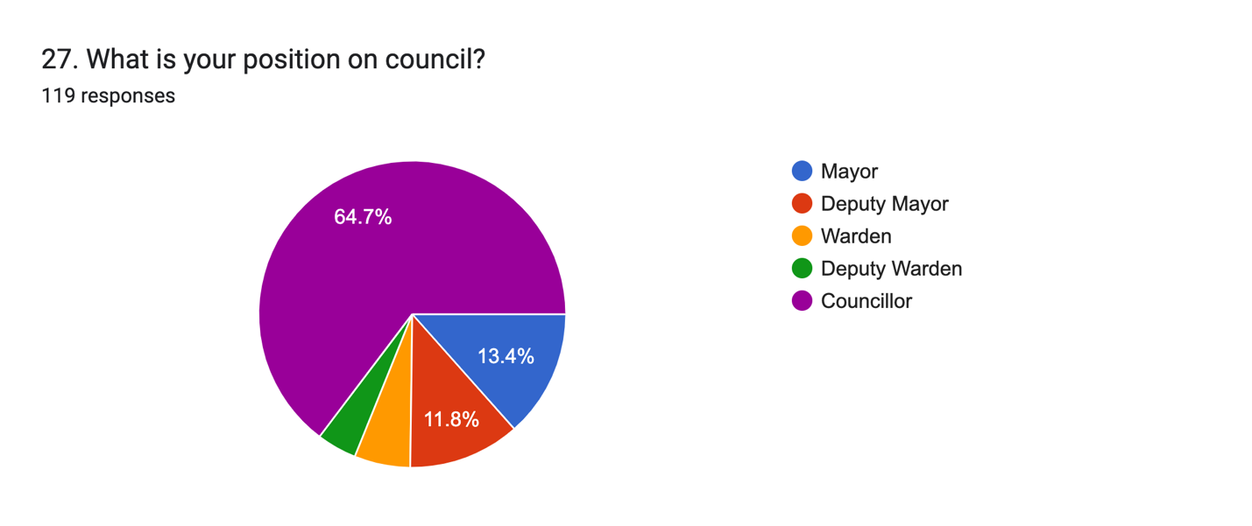
28. What is your municipality?
105 responses
HRM
Colchester
Cumberland
East Hants
Argyle
Town of Westville
Bridgewater
Antigonish County
Pictou County
CBRM
County of Pictou
Region of Queens
Digby
Middleton
Richmond
Mahone Bay
MODL
Town of Annapolis Royal
Town of Shelburne
County of Pictou
Halifax Regional Municipality
Victoria County
Town of Yarmouth
Guysborough
Annapolis Royal
West Hants Regional
Oxford
Kings
Town of Middleton
Victoria
Town of New Glasgow
Town of Lockeport
MODG
Town of Lunenburg
Town of Mahone Bay
Barrington
Halifax
Queens
Clark's Harbour
Truro
Municipality of Cumberland
Cumberland
Antigonish
Pictou county
Modg
MODY
Municipality of the Region of East Hants
municipality Of The District Of Shelburne.
New Glasgow
Prefer not to answer
Kings county
Town of Mulgrave
County of Annapolis
Town of Berwick
Town of Shelburne
Town of Antigonish
Modl
Pictou town
Town of yarmouth
Municipality of the District of East Hants
Lockport
County of Antigonish
town of digby
West Hants Regional
Municipality of Pictou
Inverness
wolfville
Town of Pictou
Town of Amherst
Town of Lunenburg
District of Barrington
West Hants Regional Municipality
YARMOUTH
Town of Truro
Wolfville in Kings Co.
Mody
St. Marys

