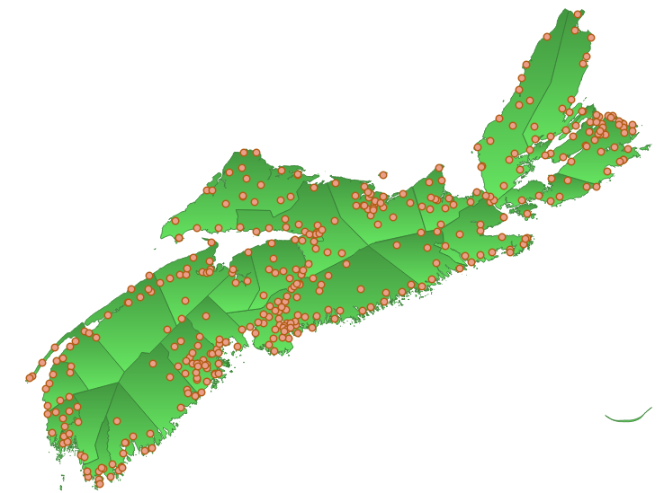

Nova Scotia Federation of Municipalities and
Association of Municipal Administrators of Nova Scotia
Joint Submission to the Fire Services Review

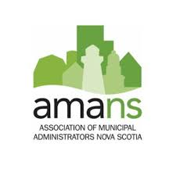


Note on Cover Image: The image on the cover of this report is a map using open-source data and GIS software showing the location of the 380 Fire Station Buildings (BLFS40 and BLFS60) across Nova Scotia.
Introduction
The Nova Scotia Federation of Municipalities (NSFM) and the Association of Municipal Administrators of Nova Scotia (AMANS) are happy that fire prevention services are being given their warranted attention in the Governance Review of Fire and Associated Services by the Fire Services of Nova Scotia Association (FSANS).
NSFM and AMANS are making a joint submission as part of this review to bring attention to critical issues and improvements from the municipal perspective. As indicated in the FSANS Request for Proposals (RFP), this review must build on the diligent and in-depth work conducted in past reviews such as the Fire Services Seniors Officials Committee (FSSOC) Final Report (2012) and the Municipal Review of Fire Services Nova Scotia (2017) (herein referred to as the Pomax Report). Recent record-breaking wildfire activity has demonstrated the impacts of climate change and rising average temperatures. Therefore, identifying and addressing issues that restrain the fuller potential of fire prevention services in Nova Scotia is as crucial as ever and NSFM and AMANS are proud to contribute to this effort.
[Executive Summary of Key Points]
Research Underlying This Report
Many issues and opportunities for improvement in fire prevention services are longstanding. Incremental improvements have been accomplished with pressing opportunities identified in review after review. To make the most out of insights and recommendations identified in past reviews, this submission is supported by research on the FSSOC Report, the Pomax Report, as well as recent After-Action Reports from wildfires in Tantallon and Barrington. Together, these reports provide valuable insights on how to improve the sustainability and effectiveness of fire prevention services.
This report also draws on insights from subject matter specialists among the NSFM and AMANS membership. A NSFM Representative on the Joint Fire Services Partnership Committee was able to share in-depth and current insights on how to support and evaluate effective fire prevention services identified by a formal review by their council in 2024. [Upcoming AMA Contribution: AMANS will be engaging CAOs that currently sit on the Department of Emergency Management’s CAO Advisory Table for feedback to inform municipal administrative perspectives on the fire services review. Questions will be distributed in a survey that address key matters in the scope of work of the FSANS RFP document. AMANS will be issuing the survey the week of August 25 requesting final feedback the week of September 8. Further municipal administrators who are not on the DEM CAO Advisory Table may also be engaged who have informed insights on fire services.]
Finally, this joint submission draws from opportunities identified by the Public Safety Working Group during a review of the Municipal Government Act in 2020. The consultation and in-depth research supporting each of these past reviews further enriches the consultation conducted as part of the current review.
Vision Underlying This Report
This submission applies a municipal lens to the findings of reports mentioned above. Key issues identified in these reports can be boiled down to issues of 1) inadequate funding, 2) the absence of provincial standards for both training and operational capacity, and 3) the fraught organizational structure that is currently enabled by fire services legislation (i.e.: Fire Safety Act, Municipal Government Act Part X, Rural Fire District Act, and the Emergency Management Act, etc.). Municipalities play a vital role in fire prevention services administration, but this role is undermined by these structural issues.
Given this central role, municipal capacity to govern is often a focus of reviews on fire services in Nova Scotia. The Pomax Report notes that the municipal ability to maintain and provide fire and emergency services is not limited by legislation but rather the lack of a structure to advise municipalities on fire service operational, training, and capital needs and sufficient sources of funding. The Pomax Report states that “with sufficient funds, municipalities would be able to 1) undertake studies to determine the fire and emergency protection needs in their communities; and 2) implement a fire and emergency services protection system commensurate with identified needs [by engaging in] public education, prevention, suppression, rescue, training, and other identified requirements.” Figuring out how to develop and support the municipal role in fire prevention services with sound administrative arrangements, sources of funding, and a broader legislative environment is key to success. Without a province-wide effort to pursue these improvements, fire prevention services will only reach their potential in municipalities with sufficient resources, leaving less-resourced areas to grapple with gaps and limited capacity.
The ideal state of fire prevention governance for municipalities includes practical administrative systems and informed municipal councils supported by a legislative environment that clearly organizes a common understanding of responsibilities, roles, and required qualifications. Financial investment or new sources of funding will support the capacity of fire departments and municipal councils to attract, train, and retain talented firefighters and use the best available equipment and technology in their service to the public. Similar to the standards that exist for the Department of Nature Resources, standards for training and operational capacity will aid targeted funding and, when necessary, evidence-informed consolidation. Municipal councils and staff already care deeply about public safety in their communities; this care will lead to effective prevention and response efforts if municipal councils are given the legislative grounds, financial support, and administrative tools necessary to govern fire prevention services. Maintaining the health and safety of fire fighting volunteers and staff before, during, and after they engage in their truly heroic will help the potential of fire departments across Nova Scotia shine more brightly than any fire that confronts their commnuities.
Each of the issues and opportunities note below are made in the interest of moving toward this ideal state.

Content (Outline for Feedback)
The points below are drawn from published reports and insights on current issues. Recommendations and supporting points are organized under the headings provided under the FSANS RFP Deliverables; these headings are in some cases merged to account for overlaps in responses or lack of input on a specific heading.
Governance and Oversight:
Content in this section will draw attention to:
- The increasing number of provincial departments overseeing aspects of fire services. A call for a focused provincial point of contact or coordination point has been recommended in past reviews. With the Department of Emergency Management as a recent addition to the Department of Labour, Skills, and Immigration, the Department of Natural Resources, and the Department of Municipal Affairs, the need for coordination seems more increasingly apparent.
- The various pieces of legislation that should be aligned and complementary, but often clash or create confusion. These include the Municipal Government Act (MGA), Fire Safety Act, Rural Fire District Act, and Forests Act. There are specific difficulties created by the Rural Fire District Act (inability to modify levy or hold fire departments accountable).
- Improvements to the Municipal Government Act, as identified in the last MGA review:
  - Amending section 294 and 296 to give municipal councils the policy tools to require annual reports and registration on the basis of provincial standards.
- The importance of provincial standards by which municipal councils will be able to assess and mandate the necessary level of preparation and capacity.
Operations: (merge with above?)
Content in this section will draw attention to:
- How standards will help to support effective and sustainable operations.
- The opportunity to build on a track record of high-quality interoperability in prior reports.
Scope of Service and Training:
Content in this section will draw attention to:
- The value of providing evaluation and risk assessment tools for municipalities to apply to their local jurisdiction. Currently, only a few municipalities have conducted risk assessments and plans to respond to these risks, which are becoming more numerous as a result of climate change.
- How Evaluation tools are useful for municipal assessments of their current fire services, but these evaluations will only have an impact if they are based on provincial standards.
- The importance of training standards and resources necessary to reach these standards. The importance of well-resourced, and responsibly administered training resources, as shown by the recent shut down of the Fire School following the avoidable death of a trainee.
- That Department of Natural Resources has training standards.
Funding Models:
Content in this section will draw attention to:
- The prospect from improvements in 1) capital funding, 2) funding for training, and 3) funding for service, such as paying volunteer fire fighters when they respond to a fire.
- Finite financial resources identified by Pomax as including: Local taxes, Provincial grants, Provincial transfer payments, Taxes specific to communities (area rates).
- How helpful the new Emergency Services Provider Fund is in improving fire service capacity and that this fund should be distributed annually or along asset lifecycle timelines.
- How past reports have identified severe financial limitations of municipalities to finance improvements with property tax/area rates.
- The value of predictable, application-based funding for fire services that will prioritize those fire departments most in need to address equity concerns with “over-resourced departments”.
- How fire departments are often purchasing their own equipment with independently raised funds and how bulk purchasing and asset management would make the most out of existing financial resources.
- That reaching the fuller potential of fire services will require upfront investment and identification of ways to reach economies of scale.
- That when special services are provided to a corporate entity, there should be a cost recovery mechanism.
- The partial solution of modifying the Municipal Government Act to allow fire departments to borrow money for justified capital expenses.
- Addressing the clash between municipal funding limitations and how the area rates or levy is established under the Rural Fire District Act.
Organizational Structure:
Content in this section will draw attention to:
- How clear, legislated responsibilities and standards help organizations perform better and more predictably.
- The importance of fire departments providing annual reports to municipal councils, to support regular reports from municipalities to the Office of the Fire Marshall.
- As identified in the MGA Review, fire departments should be encouraged to partner with other fire departments and other organizations, including for profit organizations, to build capacity when opportunities arise.
Services and Supports:
Content in this section will draw attention to:
- Amendments of section 294 and 295 of the MGA that will require fire departments to report when they are changing the level of service provision.
- The importance of supporting firefighter safety and mental well-being to retain and reward workers as identified in past reports.
Service and Dispatching Standards: (merge with above?)
Content in this section will draw attention to:
- The importance of regional, computer-aided dispatch to improve response times and coordination.
- A unified dispatch system, as found by FSSOC, would support performance-based reporting systems using measurable targets.
Administration and Coordination:
Content in this section will draw attention to:
- Fire Services Coordinator position could perhaps be compatible with the Emergency Management Coordinator position support municipal Emergency Management Organizations.
- The aforementioned importance of fire risk assessments and developing plans to respond to risks identified.
Provincial-Municipal-Volunteer Relationships:
Content in this section will draw attention to:
- The value of mutual aid agreements being formalized.
- How the Province can provide assistance in recruiting and retaining talented fire department volunteers and staff with “non-remunerative incentives” (FSSOC 2012)
- The importance of aligning public safety districts between Emergency Management, Policing Service, Emergency Health Services, if new fire service districts are to be developed.
- How the Provincial government can pave the way to improved fire preventions services with resources, standards, and clear points of contact among the various departments overseeing fire prevention services, while municipalities can pursue these improvements by overseeing fire departments. Fire departments, be they volunteer, paid, or composite, all want to do a good job and just need to tools necessary to do so.
- That clear grounds should be provided for consolidation should be established to support an apolitical decision on when consolidation is necessary.
- Amendments to section 302 of the MGA that would improved language surrounding fire service provision agreements between Towns/Rurals/Villages with termination clauses, model provisions, mediation processes, asset ownership, fire commission creation
- That if other supports (i.e.: funding, standards, provincial organizational structure) were available, municipalities being required to conduct mandatory fire risk assessments would be viable and helpful.
Concluding Remarks
Concluding remarks will summarize key points and express support for the review.

