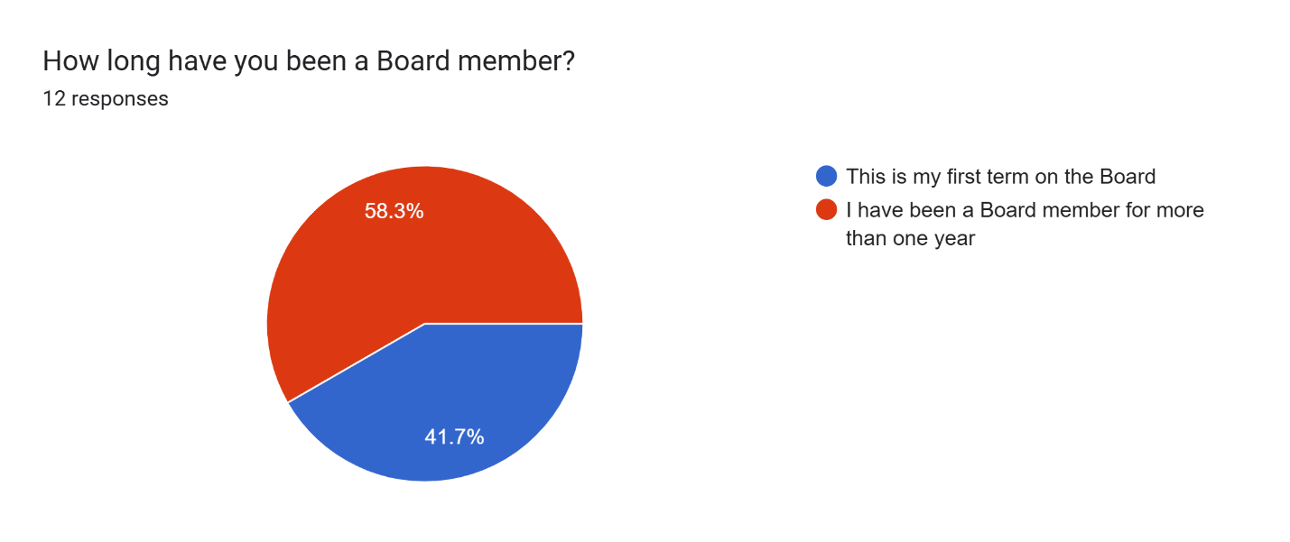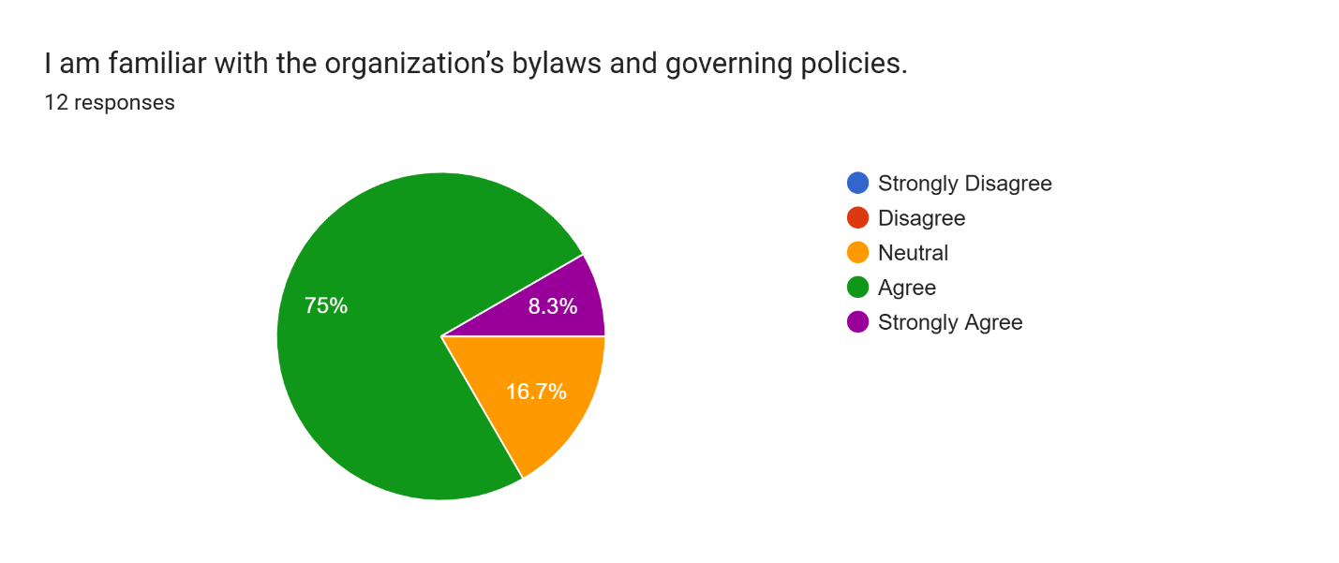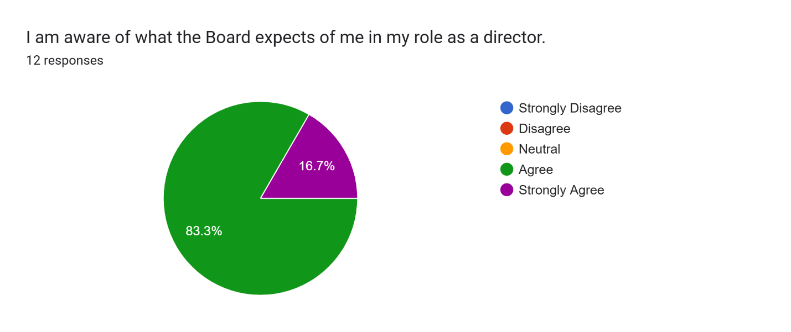

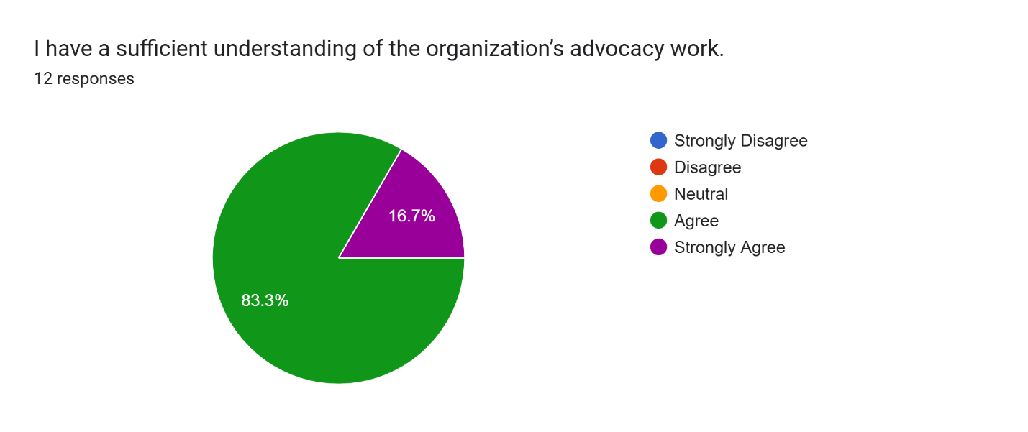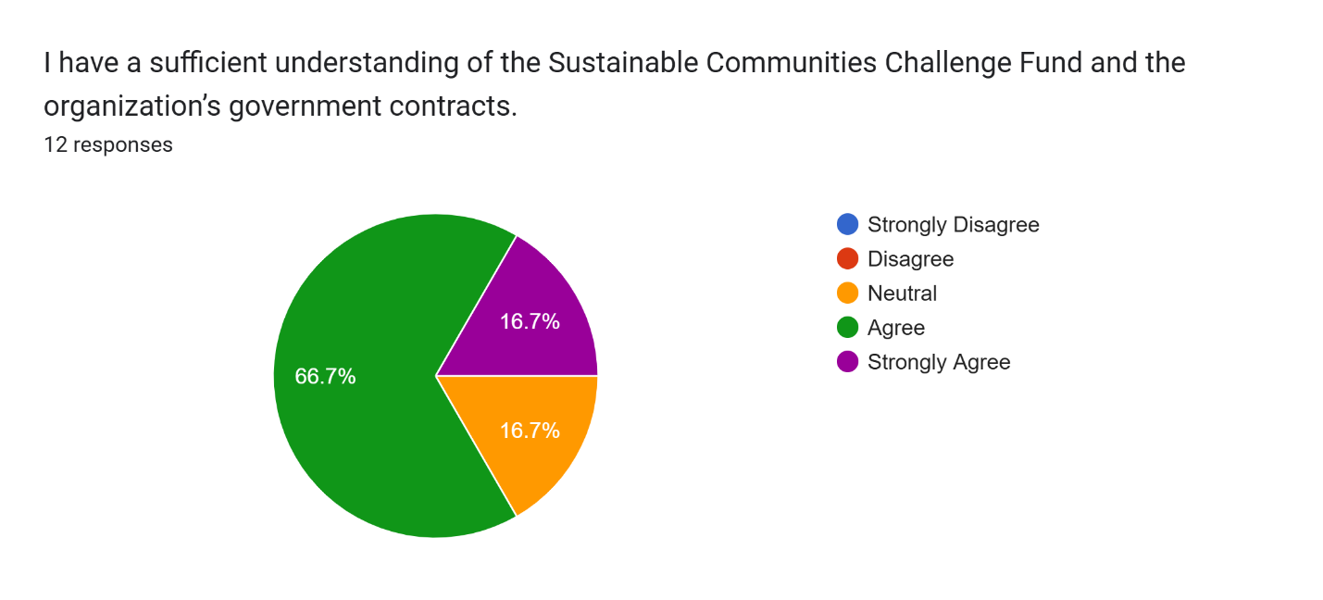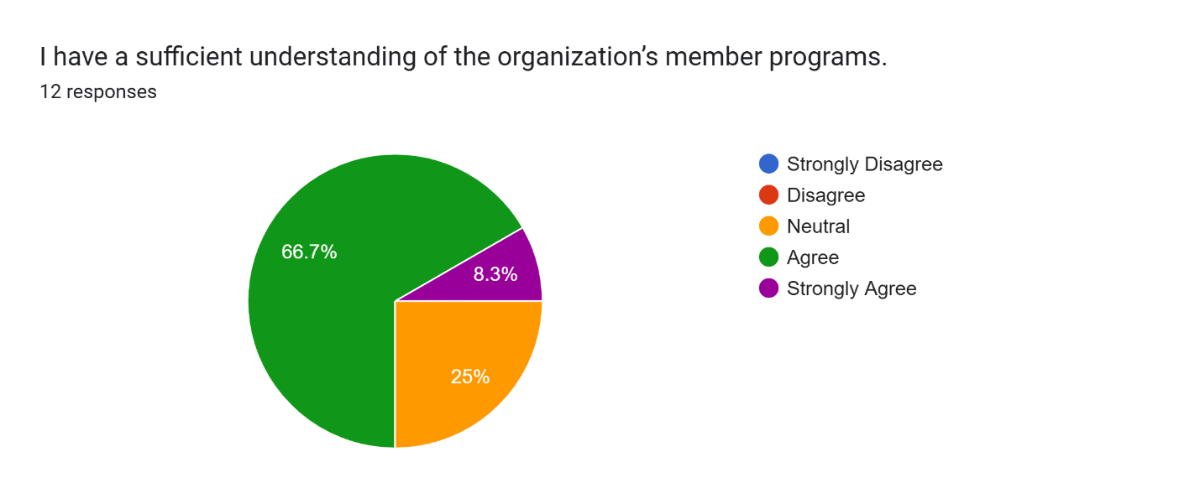
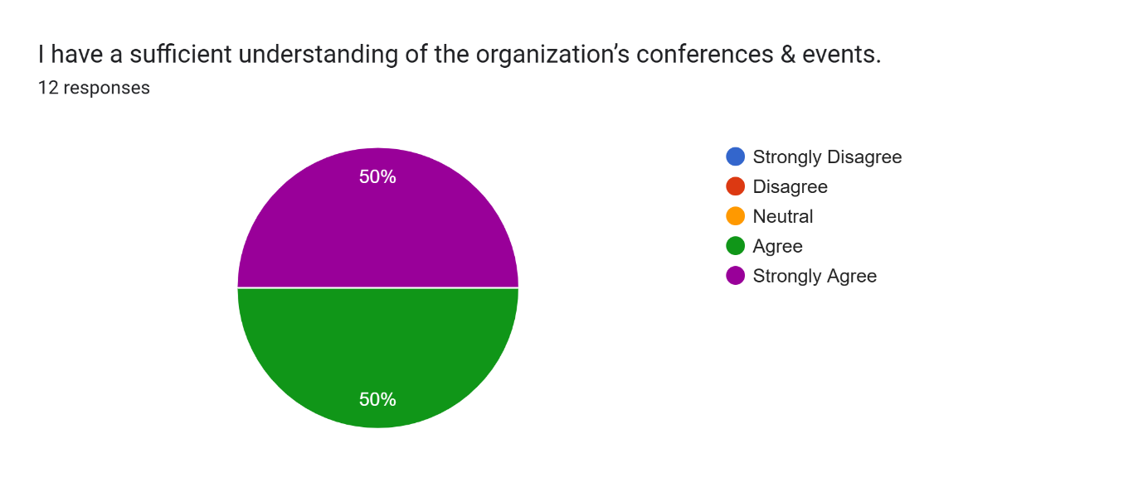
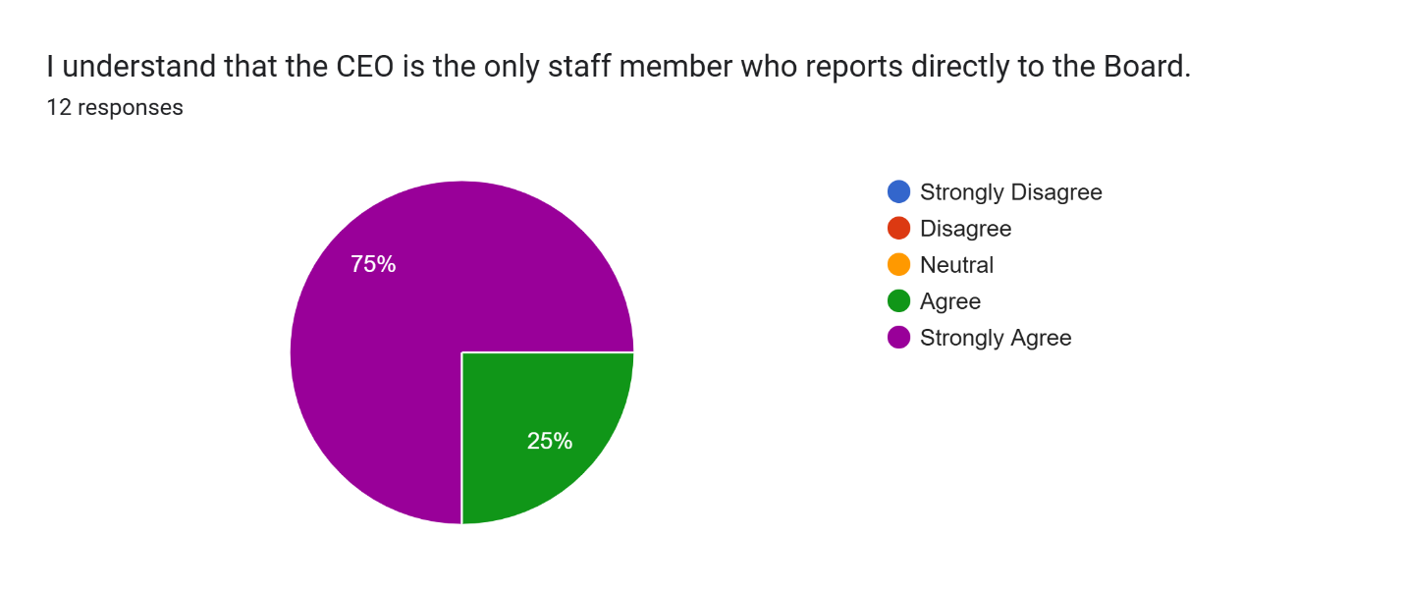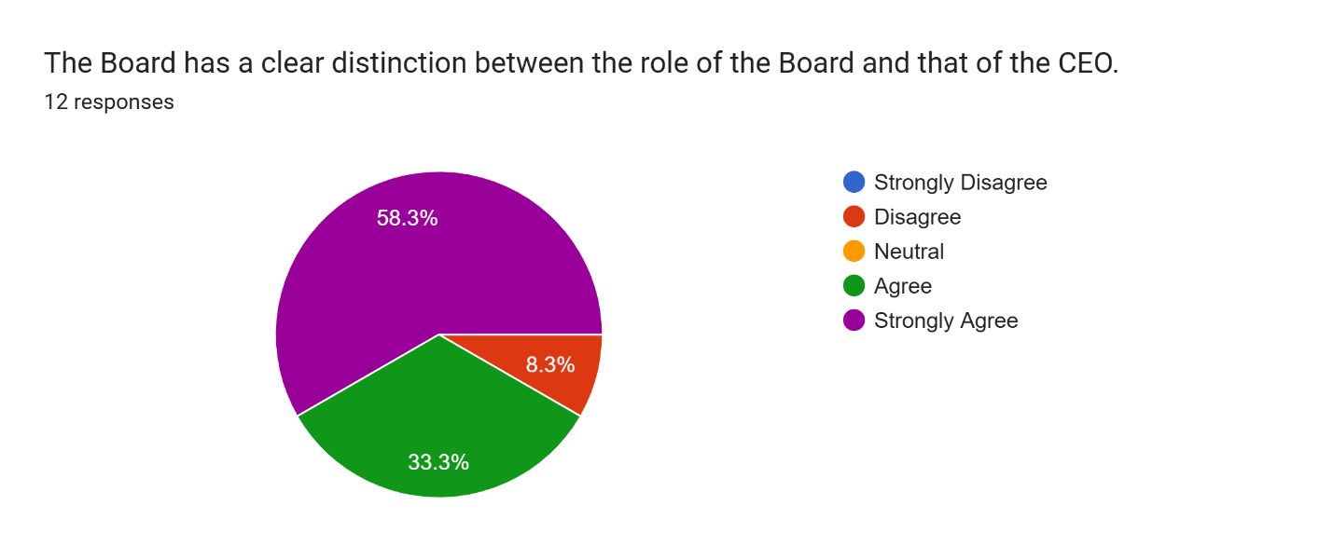

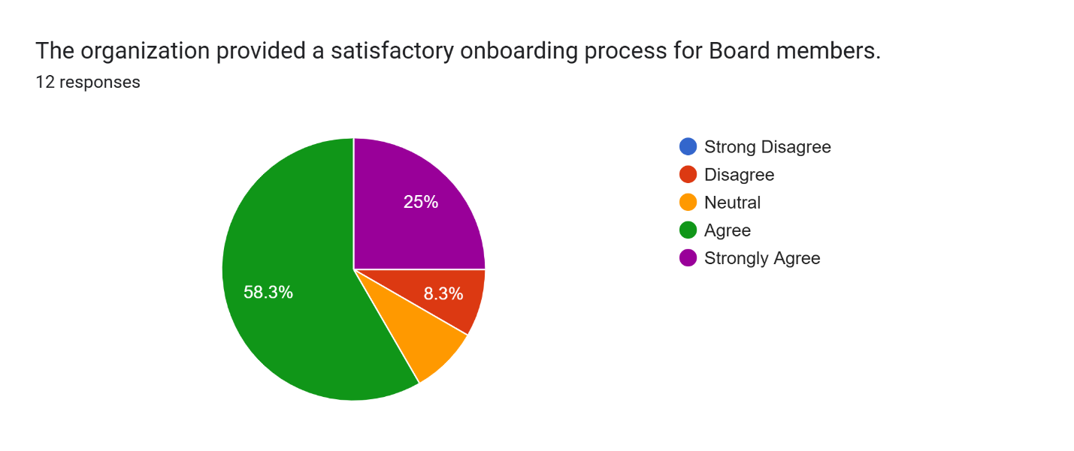
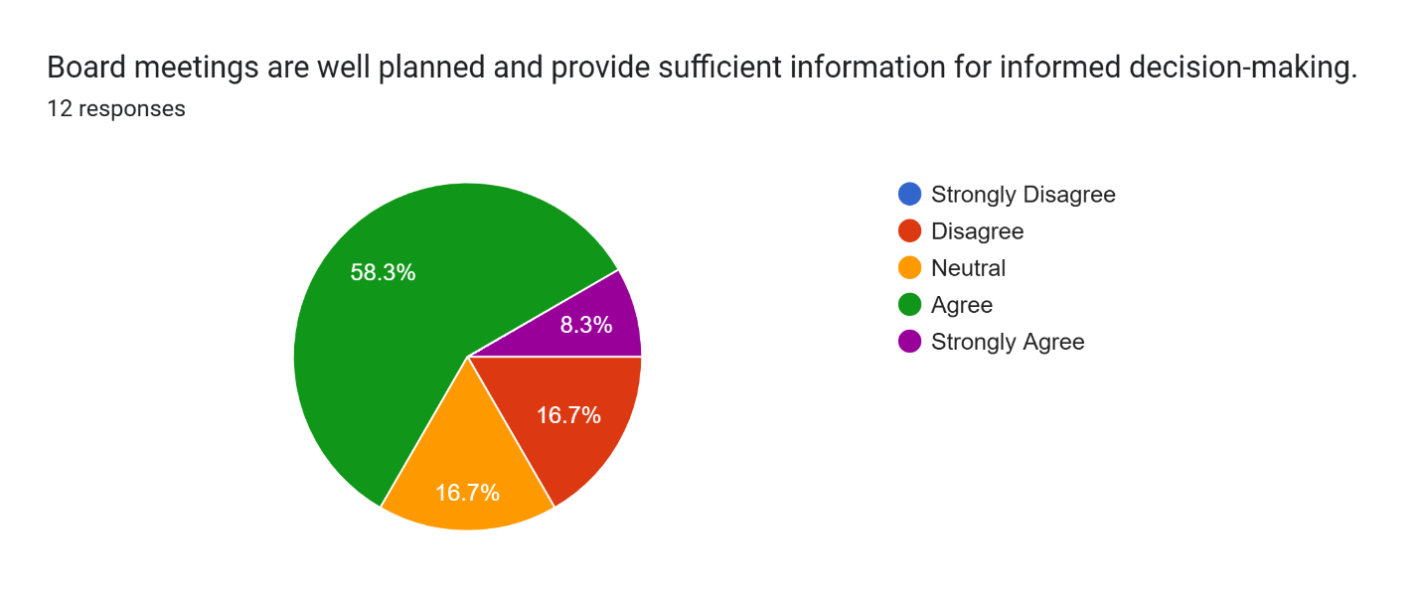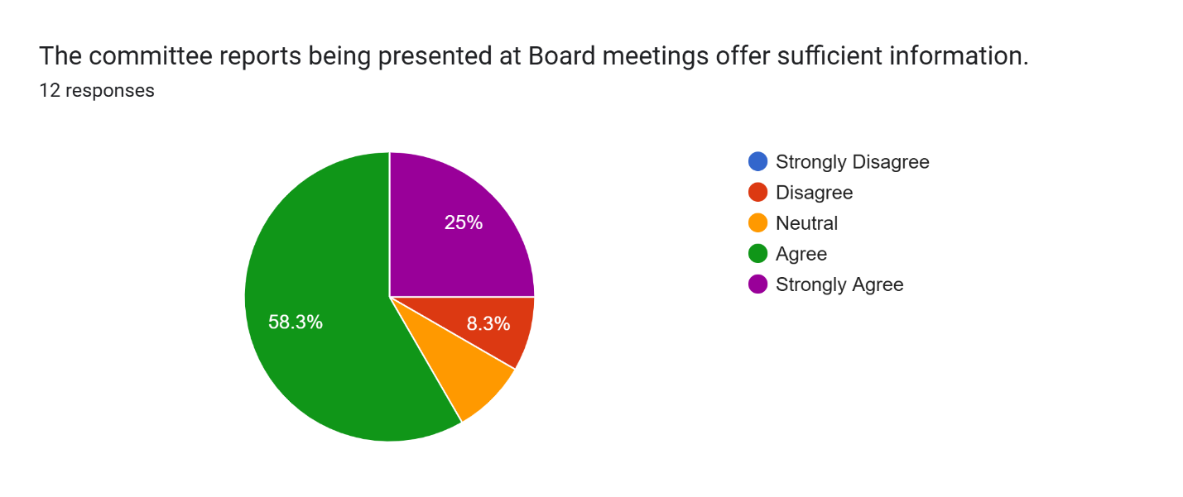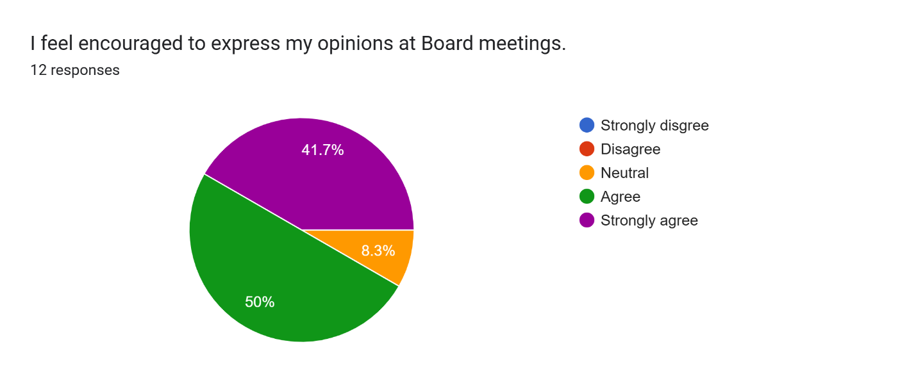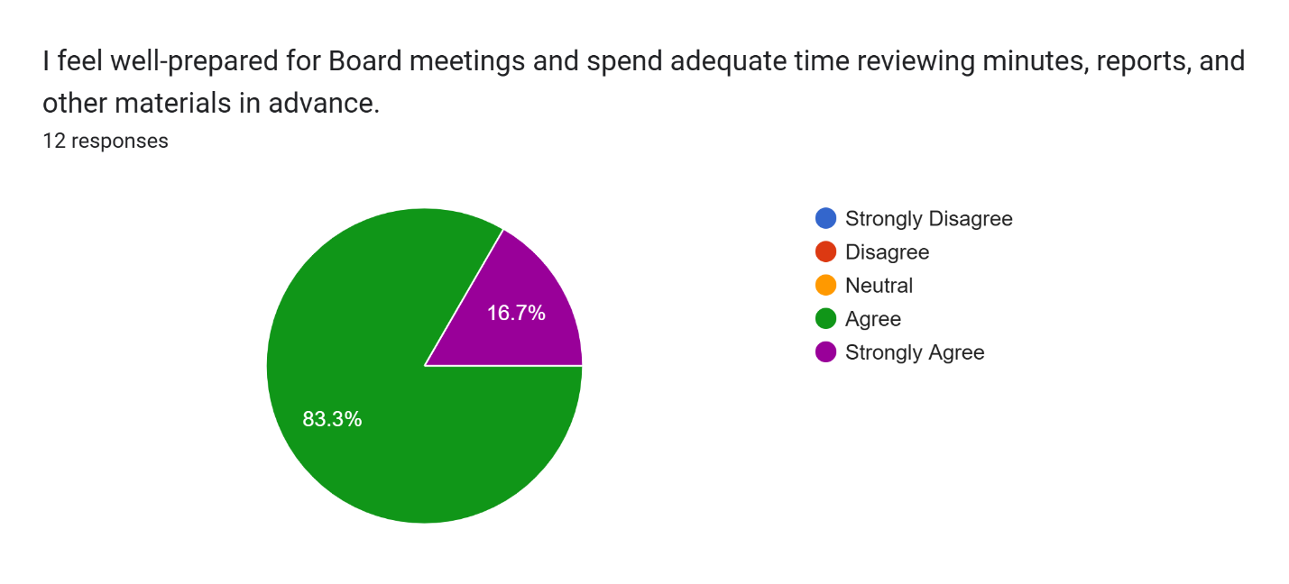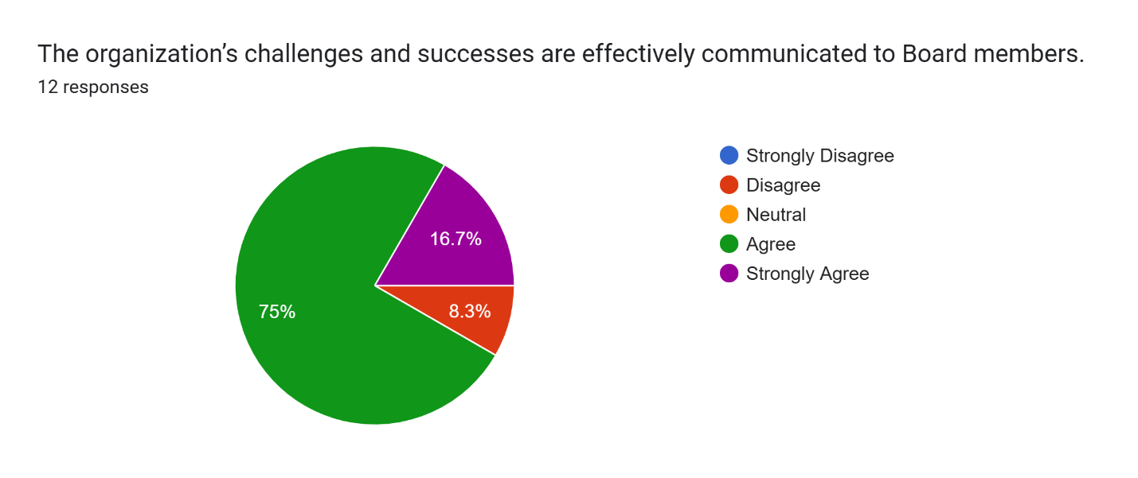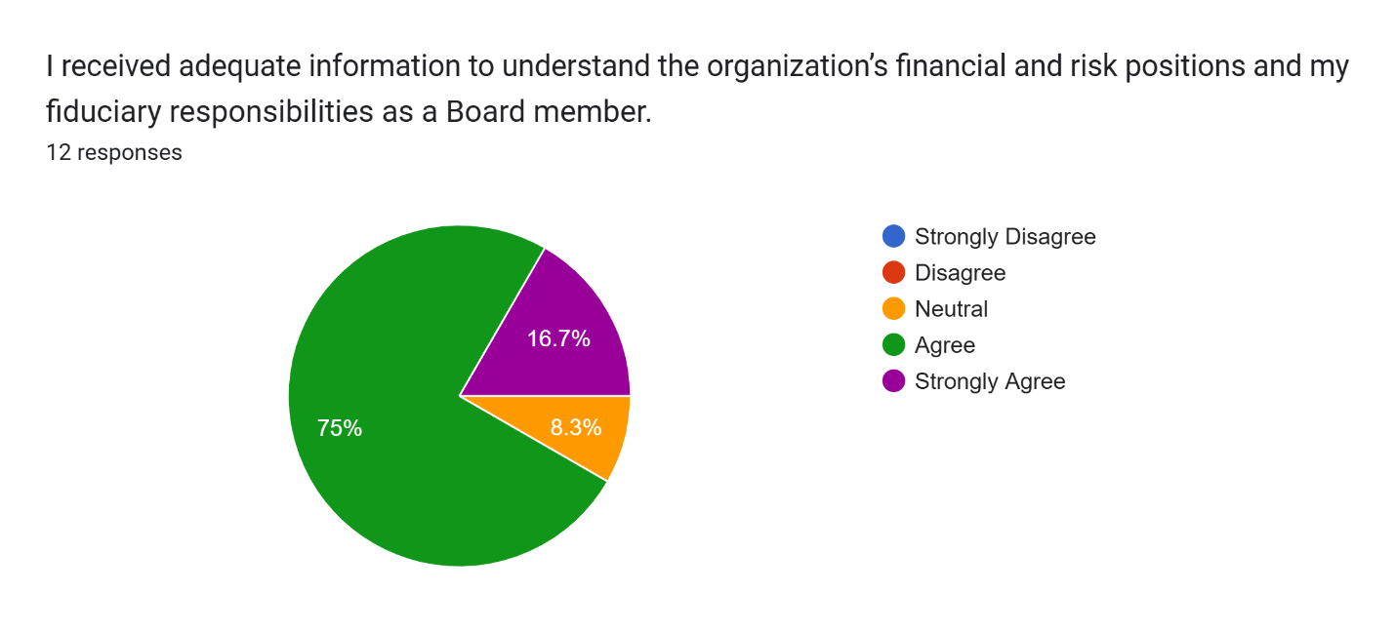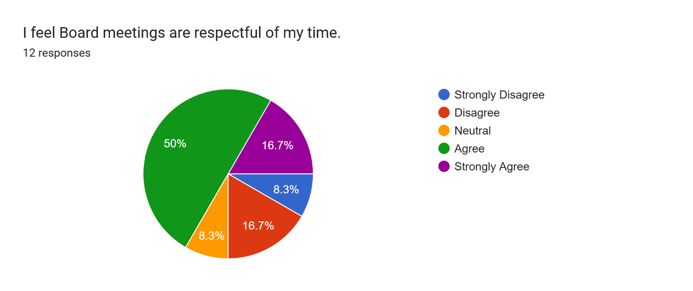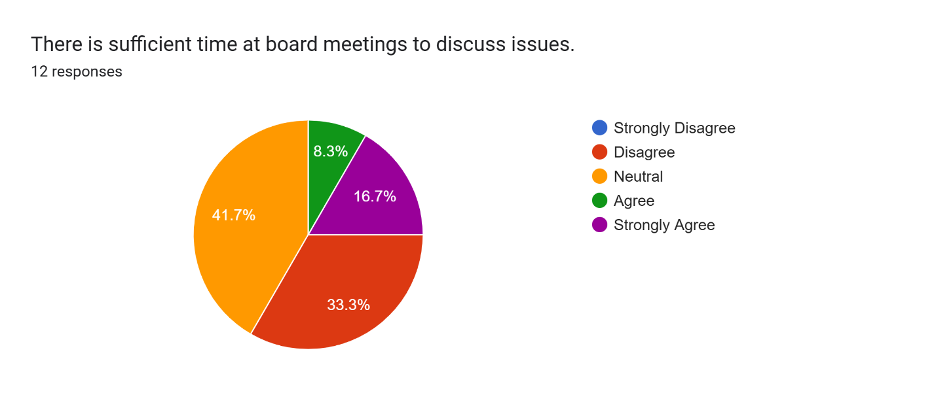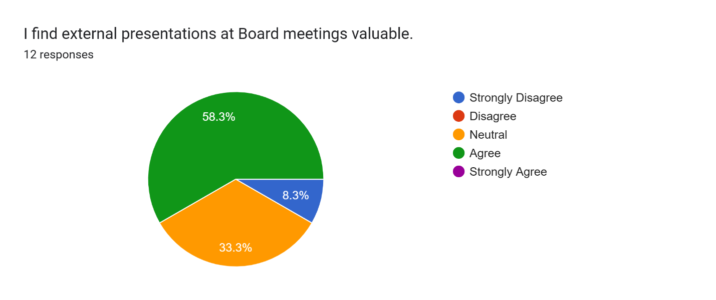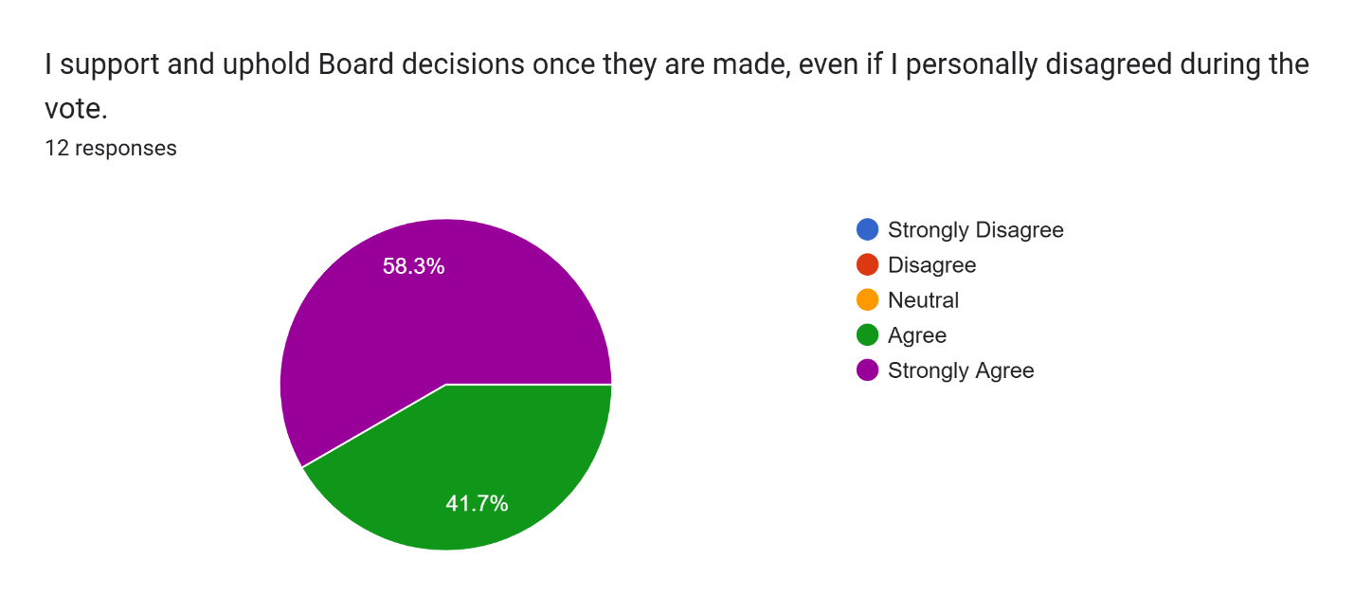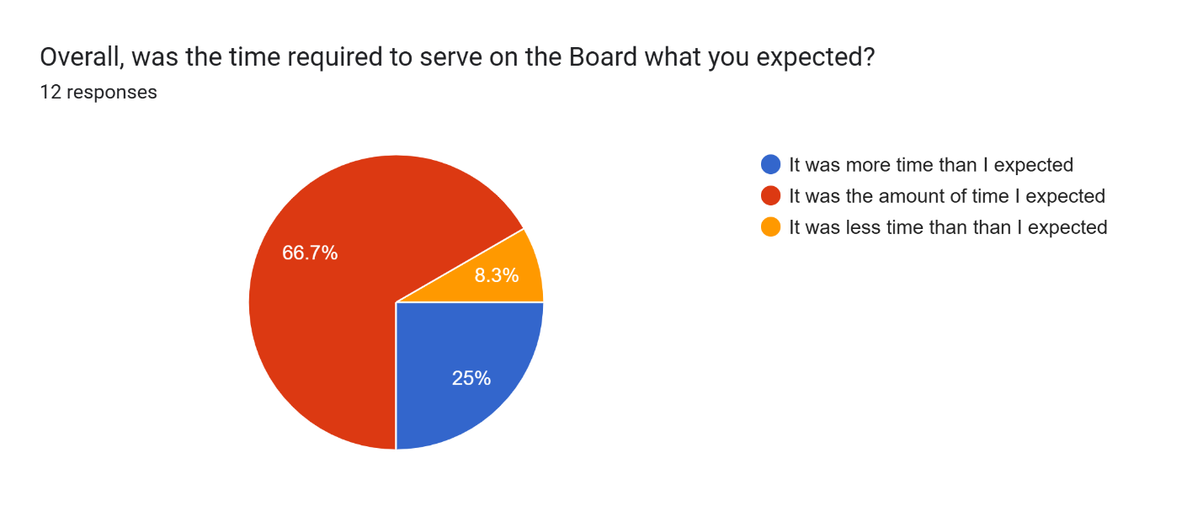
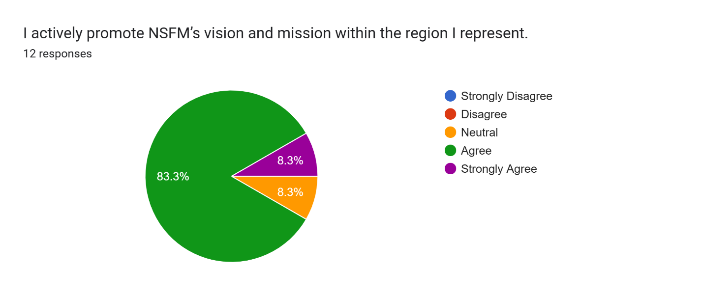
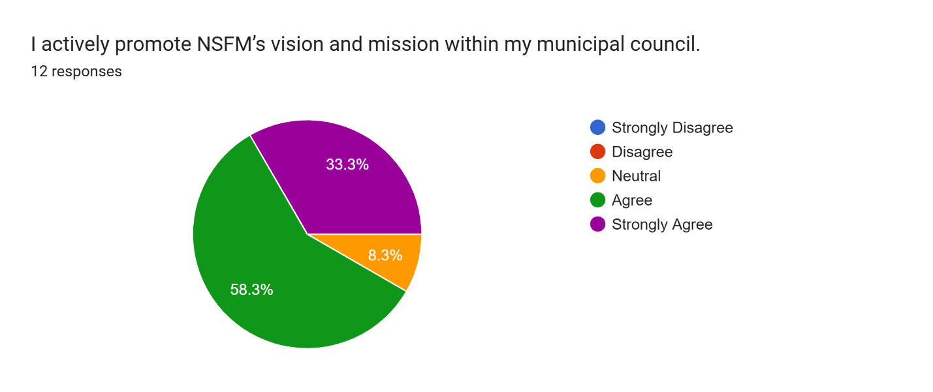
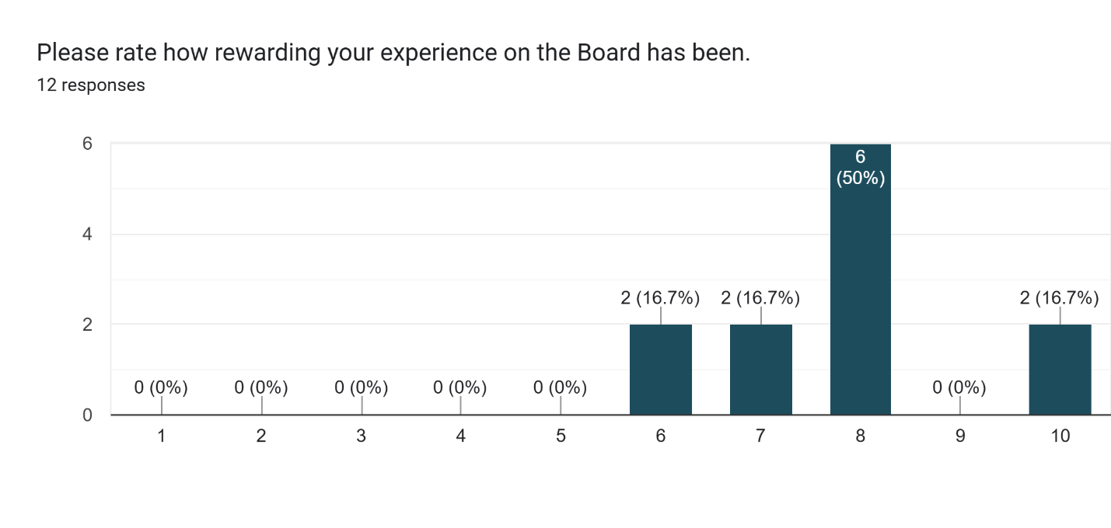
Please comment on your overall experience serving on the Board, and whether you would recommend this experience to others.
I am honoured to serve on the board. I consider other members mentors.
I would recommend this experience to others. Members need a clearer understanding of the advocacy work and lobbying work that NSFM is able to achieve on behalf of elected officials. With that clearer understanding, I think you’d see more folks stepping up to serve on the board.
Yes this is a good organization, and I would promote this to others who may want to step forward and take a leadership position at the Provincial level.
My experience has been a good one and yes I would recommend others to offer for a board position.
I thoroughly enjoyed serving because of the unique perspective it gives and better understanding of all 49 municipalities and I have recommended the role to many and will continue to do so.
I would and do recommend others to consider serving on the Board and committees.
The board work complements my work as a councillor. I have encouraged others to engage in the work of NSFM — whether at a board or committee level.
The inner workings of any organization are always eye-opening to newcomers, but the CEO and the support staff are excellent at their jobs and areas of expertise. There is never any situation where there is a wrong question. They are very supportive and helpful. If asked if it were a worthwhile experience, I would not hesitate to recommend the experience.
Overall great experience. The board meetings are too long. Meeting monthly for 2 hours at a time would be better. We often do not have time to talk about everything we want to as the meetings are jammed packed- items get added in the last minute, and people cannot be prepared when this happens. Also, sitting for 4 hours with no breaks or anything scheduled, it makes this challenging, and engagement goes way down after 2 hours. This makes it difficult for members to add things they want to discuss, as we cannot get through our entire agenda as it is. The group is great, and the experience is good, but these long meetings are a hard sell when recruiting others.
I would recommend the Board to others primarily due to the insight you gain into issues affecting municipalities across the province.
Reflect on something you would like to have known before becoming a Board member or training you would have liked to receive.
I think New NSFM members should be taught basic rules of order and how to write policy.
I would have liked to have known how long, and inefficiently run, the board meetings would be. There is no excuse for 4 or 5 hour online board meetings to begin with, but even with that length of time the entire agenda was seldom completed. There must be a much tighter hand applied to creating agendas AND to chairing meetings. Give every member one chance to speak before anyone gets a second chance to speak - second chances to speak are only if something new needs addressing or something old needs correcting. Incoming presidents need to be advised of the requirement to adhere to orderly meetings.

More education on NSFM member benefits/programs and government program outcomes.
How important our relationship is with the Province.
It took me a while to understand the board’s multiple areas of engagement and staff’s roles.
How to better interact with other municipal leaders and how FNSM can facilitate this.
The time commitment is underestimated. The timing of meetings during regular working hours can be a challenge (flexibility to start them even one hour earlier would be helpful). Also, scheduling a full-day and a follow-up meeting next to the conference is challenging.
I could be doing a better job of promoting NSFM within my region. Having the list of contacts would be helpful. I think taking some time during meetings to talk about what priorities NSFM would like Board Members to discuss/promote might be a great way of helping us help the organization better.
Comment on how well you feel the organization represents the entire membership.
Pretty well.
Lean into describing NSFM as an advocacy and lobbying group. NSFM is absolutely a political organization which is why it’s so important to keep AMANS at arm’s length - CAOs are meant to be apolitical. NSFM as an organization representing elected officials, is inherently political. Own that, lean into it, and NSFM will represent its members even better than it already does.
It does a decent job juggling the various issues of the rurals, towns and regional governments. Some issues are specific to each and for some unknown reason we sometimes blend them which isn't great.
The organization does a good job of representing the membership on its priorities.
It does a great job of keeping issues to the broader context
It represents members well, but not all members are aware of such or understand the important role played by the organization.
NSFM represents its 49 municipal member units well. The question is whether the voting members feel represented. The organization is in the midst of needed transformation. Mission critical is engaging voting members to build support for those changes.
The organization does a great job representing the entire membership; however, I don't feel that the membership is aware of or takes advantage the services available.
The organization does a good job of representing all units from my experience on the board.
Very well - balanced.
Any other comments?
There are councillors that wish they could run for board, but their Municipalities won't support them. (They don't pay for the conference and associated expenses.) It really is a pity.
The singular reason I did not re-offer is the length of board meetings and how inefficiently they ran. Keep the two full-day meetings at the conferences but make the virtual board meetings monthly and a maximum of two hours with agendas set accordingly and no extraneous presentations. The majority of the presentations in this past year were already made directly to municipal councils, so as NSFM board members we effectively sat through the same information twice (albeit slightly more detailed at NSFM). The meetings need to be chaired with an iron fist - we’re all elected officials; we can all talk given the chance and we will…some will do so completely off topic. Much stricter adherence to some form of rules of order desperately needs to be followed when it comes to speaking.
The next change to the bylaws (Spring 2026, ideally) should be to extend the President’s term to two years. One year is nonsensical - barely enough time to get up to speed and they’re gone. Also needed to jive with FCM.
Sometimes the meeting agendas have too much on them and many of the important decisions are at the back end of the meeting. This leads to us rushing through the agenda when sometimes we need more time to discuss issues.
I enjoyed the sense of community NSFM board created for me and made lifelong friends.
The broadening of NSFM’s income stream has allowed growth but it has also transformed relationships — with members, with AMANS, with provincial government agencies. Our primary role is to be the voice of municipal government in Nova Scotia. That advocacy role must remain at the core of mission. All of the programs must continue to be tested against the backdrop of that advocacy.
Thanks to staff for all their efforts.

