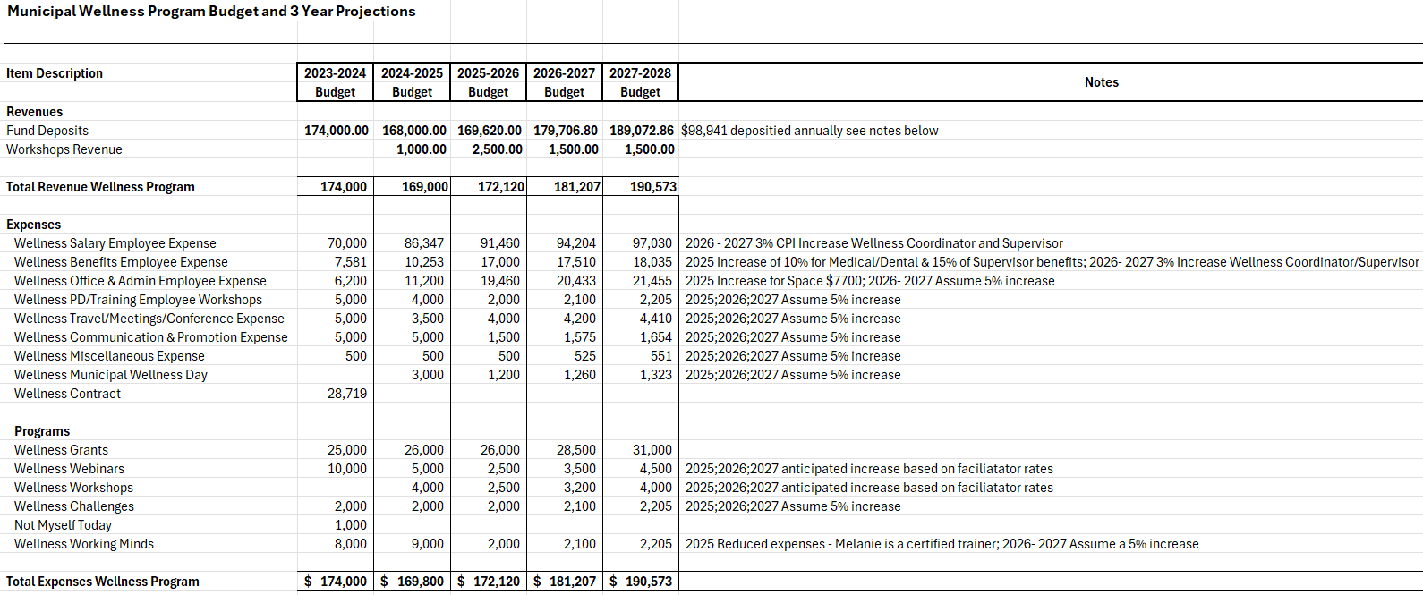
2024-2025 | Budget | Actual | Percentage
Salary & Benefits | $96,600.00 | $102,796.58 | 68.72%
Administration | $11,200.00 | $12,380.67 | 8.28%
Workshops, Travel & Communication | $7,500.00 | $4,970.98 | 3.32%
Wellness Grants | $26,000.00 | $24,000.00 | 16.04%
Programs | $28,500.00 | $5,446.07 | 3.64%
Total Expenses | $169,800.00 | $149,594.30 | 100.00%

Salary & Benefits (April 1, 2024 – March 31, 2025)
- Melanie Bower – Salary: $82,361.82
- Rebecca Toole – 15% Allocation: $9,671.51
- Benefits (EI, CPP, reclass entries, adjustments): $10,763.25

Total Salary & Benefits: $102,796.58

Office & Administration (April 1, 2024 – March 31, 2025)
- Supplies & Printing
- Insurance Allocations
- IT/Software/Subscriptions
- General Admin/Other

Total Office & Administration: $12,380.67

